PARAMETERS OF ATMOSPHERIC PRESSURE AIR PLASMA

Ardelyan N.V., Bychkov V.L., Kosmachevskii K.V., Abakumov V.I., Belousov A.D.

M.V. Lomonosov Moscow State University, [bychvl@gmail.com](mailto:bychvl@gmail.com)

Plasma-chemical processes in air are considered. On the basis of numerical modeling and analytical analysis, the background concentrations of the main charged particles under normal conditions in dry and moist air and at high power of fast-particle sources due to seismic activity are determined. The analysis of the plasma composition of air is carried out depending on its humidity..

OhIo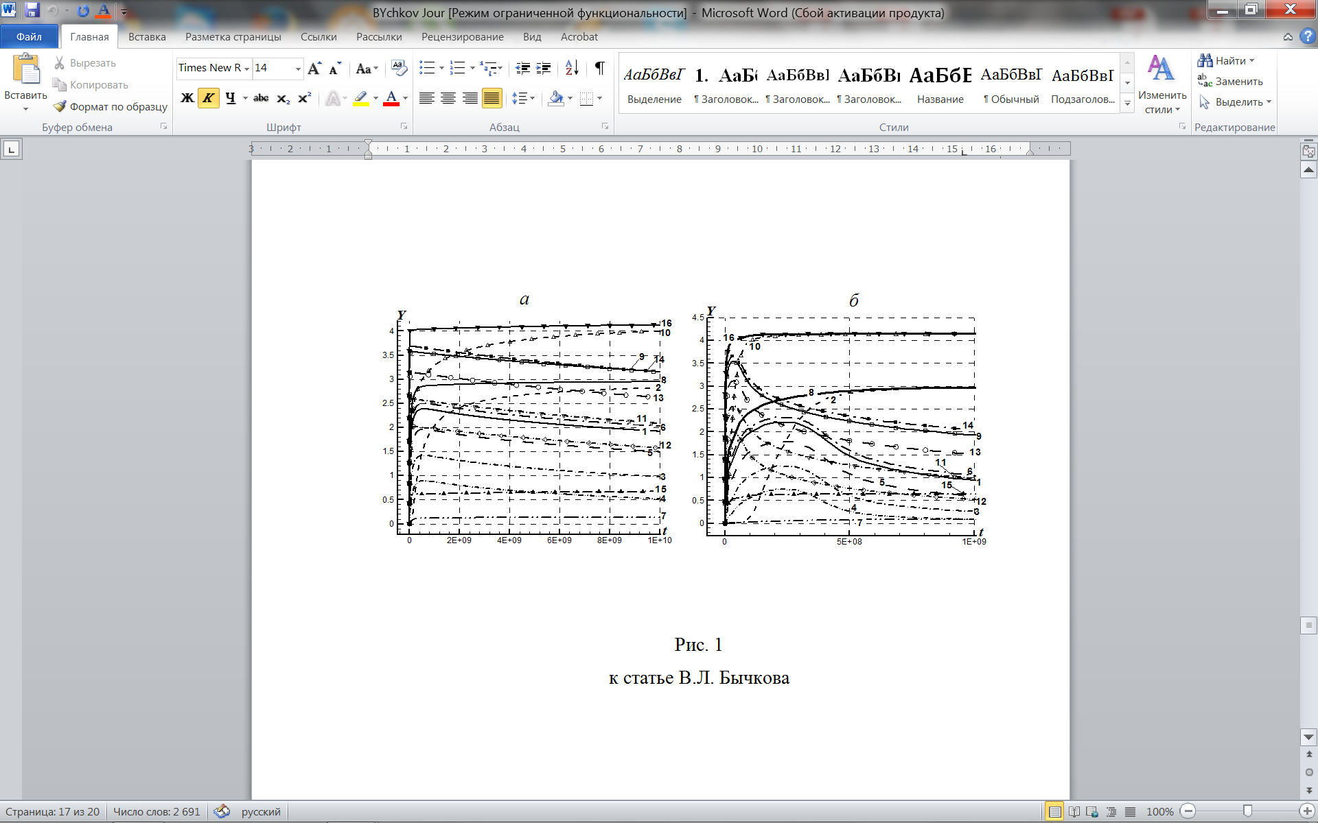 a) b)

**Fig. a.** Time dependence of the concentrations of charged particles at background ionization rate W = 144,and 3.16⋅104 eV⋅/(cm3⋅s) in dry air at electric field strength: E = 1 V/cm, at background ionization rate W = 3.16⋅104 eV⋅cm-3⋅s-1 lines are complemented by geometric symbols. The concentrations of the following charged components

1 and 9 – , 2 and 10 – , 3 and 11 – , 4 and 12 – , 5 and 13 – , 6 and 14 – , 7 and 15 –, 8 and 16 – . (t, microsec, Y, cm-3)

**Fig. b.** Time dependence of charged particle concentrations in moist air. The concentration of water vapor is 0.1%, the electric field strength is E = 1 V / cm. The concentrations of the following cluster ions: 1 and 3 – , 2 and 4 – . Lines 1 and 2 - at background ionization rate W = 144 eV⋅/(cm3⋅s); lines 3 and 4 - at background ionization rate W = 3.16 • 104 eV⋅cm-3⋅s-1.

The plasma concentration reaches values of the order of 103 cm-3 in normal air and 104 cm-3 under conditions of possible geotectonic activity.