Properties of Alfvén oscillations in the TUMAN-3M tokamak ohmic plasma
Abdullina G.I., Askinazi L.G., Belokurov A.A., Zhubr N.A., Kornev V.A., Krikunov S.V., Lebedev S.V., Razumenko D.V., Tukachinsky A.S.
Ioffe Institute, St Petersburg, Russian Federation, Abdullina@mail.ioffe.ru
The study is devoted to the determination of the location and type of Alfvén oscillations in the range 0.7 – 2.1 MHz observed in the TUMAN-3M tokamak plasma in ohmically heated discharges. The main attention is given to experiments in deuterium plasma with an ohmic LH transition, at which a strong perturbation of the plasma density profile is observed. Interest in the consideration of such discharges is due to a recent study [1], in which a noticeable deviation in the dependence of f (v_{A}) on Alfven velocity v_{A} from the linear one (Fig. 1a) was found. When calculating v_{A} in [1], the chord-average density $\overline{n}$ was used instead of its local value; the difference between the local (in the location region of the Alfven mode) and the chord-average density may be the reason for the observed deviation of f(v_{A}) from linear scaling. This difference can be especially pronounced during the transition of the plasma from L to the H mode, when peripheral transport barrier is formed. As shown in this paper, the distortion of the f (v_{A}) dependence is eliminated if the local plasma density values in the center of the discharge are used instead of the chord-average values for calculation the Alfven velocity, see Figure 1.
The procedure used consisted in selecting a region in plasma density profile in which deviation of calculated Alfven frequency from experimentally measured one is minimized throughout the density evolution caused by the LH-transition. As a result, it was found that the best match is reached when this region is located in the core plasma, r/a <0.5. The fact that this region occupies an essential part of plasma cross-section points to the global nature of the mode. An analysis of the evolution of the signals of the poloidal array of magnetic probes indicates rotation of the mode in the direction of the electron diamagnetic drift. These characteristics make it possible to identify the observed mode as GAE (Global Alfven Eigenmode) and at the same time exclude the TAE mode (Toroidal Alfven Eigenmode). The dependence of the phase delay on the poloidal angle makes it possible to determine the poloidal mode number m~2.
The study was supported by Russian Science Foundation (Project # 16-12-10285) and by Ioffe Institute.
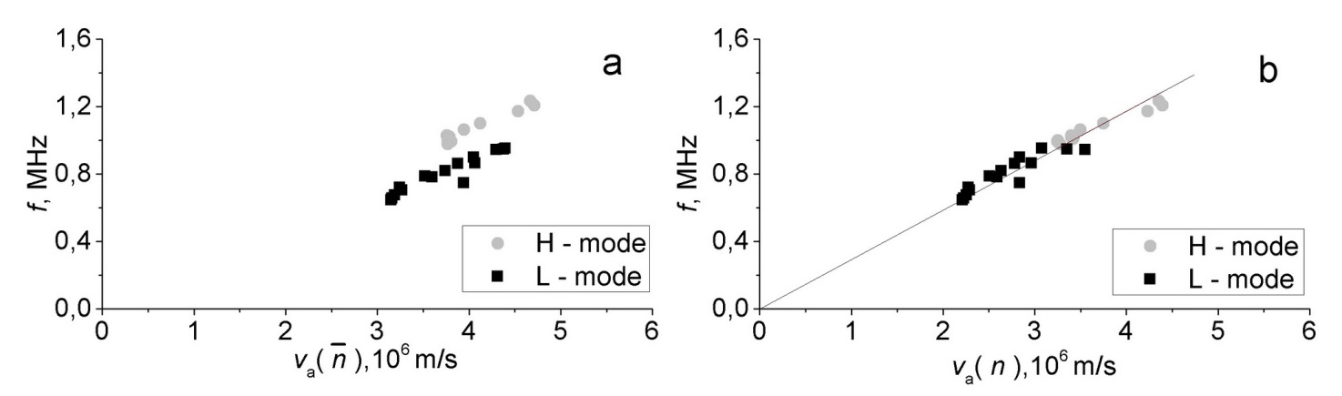
Figure 1 - Frequency dependence on the Alfvén velocity: a) v_{A} is calculated making use of $\overline{n}$. b) v_{A} is calculated making use of $n$.
References
- Lebedev S.V. et al. // 43nd EPS Conference on Plasma Physics. 2016. P. 5.063.

