observation of ball-shaped streamers at a nanosecond breakdown of point-to-plane gaps under conditions of generation of runaway electrons
Beloplotov D., Tarasenko V., Sorokin D., Lomaev M.
Institute of High Current Electronics SB RAS, Tomsk, Russia, rff.qep.bdim@gmail.com
The formation of streamers in a point-to-plane gap with length of 3 mm at applying nanosecond voltage pulses of positive and negative polarities across the one was studied by high-speed shooting methods. The gap was filled with different molecular and atomic gases: air, nitrogen, hydrogen, methane, argon, helium, neon. Gas pressure was varied from 12,5 kPa to 400 kPa. Glow of plasma during a pre-breakdown stage of the discharge was registered with an ICCD camera. It was established that ball-shaped streamer forms in the gap (fig. 1). Its shape didn’t depend on the polarity of voltage pulses and the kind of gas. At a gas pressure up to 100 kPa the first glow was observed at a distance of ≈1 mm from the edge of the pointed electrode, irrespective of its polarity, as well as the kind of gas. The increase in gas pressure led to movement of the zone where the first glow is observed toward the pointed electrode. With a negative polarity of the pointed electrode, the beams of runway electrons passed through 10 µm-Al-foil electrode (anode) were registered with a collector.

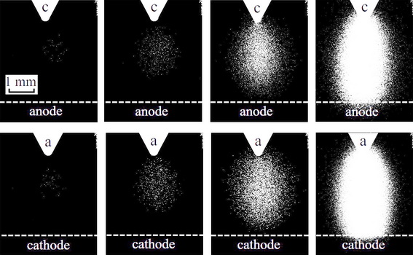
Fig. 1. Images of plasma glow at different instants of the pre-breakdown stage of nanosecond discharge in atmospheric pressure air at both polarities.
The work was performed in the framework of the Russian Science Foundation (the project #17-72-20072).

