CHARACTERISTICS OF THE ELECTRON DRIFT IN HELIUM WITH COPPER vaporS: DRIFT SPEED, IONIZATION COEFFICIENT OF TAUNSENDE AND ELECTRON runaway
V.S. Kurbanismailov, ¹S.А. Maiorov, G.B. Ragimkhanov
Dagestan State University, Makhachkala, Russia, vali_60@mail.ru
¹Prokhorov General Physical Institute of the Russian Academy of Sciences, Moscow, Russia,
mayorov_sa@mail.ru
The properties of a gas-discharge plasma in a mixture of an inert gas in the presence of metal vapors are of great interest for a variety of applications [1]. In addition, the process of formation and development of a pulsed discharge in the inter electrode gap can also be accompanied by sputtering of the metal electrode [2], and metal vapor, even at low concentrations, due to the lower ionization potential, significantly affect the kinetics of the discharge. In this paper, we consider, as an example, the drift of electrons in helium with copper vapor, since copper vapor lasers are widely used, and the results of theoretical studies and numerical modeling leave many unclear questions [3, 4].
The electron drift characteristics in helium with copper vapor are calculated and analyzed with a reduced electric field strength in the range E/N=0.001-3000 Td. The influence of the concentration (fraction) of copper on the kinetic characteristics of the discharge-the coefficients of diffusion, mobility, and the ionization frequency-is studied. Particular attention is paid to the effect of runaway electrons.
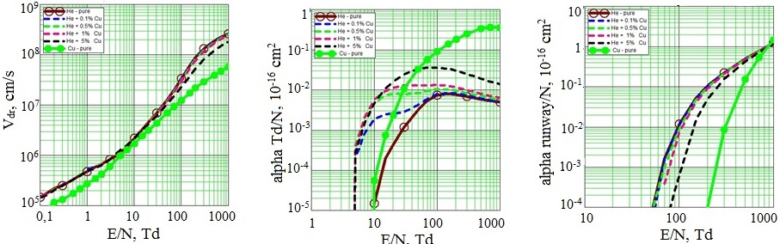
Fig. 1 | Fig. 2 | Fig. 3
In Fig. 1 shows the dependence of the drift velocity of electrons on the reduced electric field strength E/N in pure helium, copper vapor, and also in a helium mixture with 0.1%, 0.5%, 1%, 5% copper atoms, and Fig. 2 and Fig. 3 - the analogous dependencies of the reduced Townsend ionization coefficient and the electron runaway coefficient.
It is shown that even small additions of copper atoms to helium, starting with a fraction of a percent, strongly influence the discharge, especially on the characteristics of inelastic processes.
References
- Tarasenko V.F., Yakovlenko S.I. // Physics Uspekhi. Vol.174. №9. P.953-971.
- Kurbanishmailov V.S., Omarov O.A., Ragimkhanov G.B. et al. // Plasma Physics Reports. 2016. Vol. 42. No. 7. P. 687-698.
- Babich L.P. // Physics Uspekhi.2005. T.175. №10. P.1069-1091.
- Ulyanov K.N. // High Temperature. 2005. T.43. №5. P. 645-656.

