GRAVITY EFFECTS IN ATMOSPHERIC-PRESSURE PLASMA JET ARRAYS: HE/O₂ AND AR/O₂ INTO HUMID AIR
Babaeva N.Yu., Naidis G.V., Panov V.A.
Joint Institute for High Temperatures Russian Academy of Sciences, Izhorskaya 13, Moscow 125412 Russia, nybabaeva@gmail.com, gnaidis@mail.ru
Non-equilibrium atmospheric-pressure plasma jets and jets arrays are one of the main plasma sources used in biotechnology and plasma medicine. A rare gas or a mixture of a rare gas with a small percentage of a reactive gas such as O₂ are often used as a plasma-forming gases. One solution to increase the area treated is to group many jets together to form an array [1].
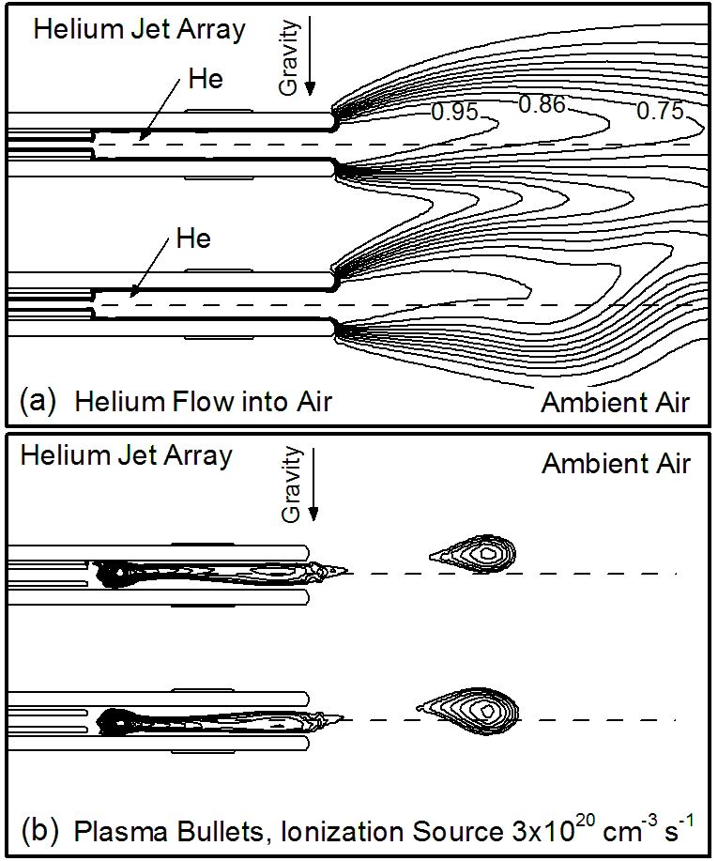
In this work, we discuss results from computational investigations of the properties of a single jet and two jets arrays operated in He and Ar. Helium or argon gas with small addition of oxygen is flowing through the tubes into ambient humid air. We show that jet–jet interactions primarily depend on the properties of plasma forming gas through the tubes. For helium, plasma tends to divert from the axis of the tube while for argon jets plasma propagates more directionally. Such a behavior can result primarily from the gravity effects as well as from electrostatic, photoionization and gas dynamic origins. For example, steady-state helium flow deviates from the tube’s axis due to the gravity thus producing the distorted arching path for the plasma. As a result, lectron impact ionization source (perceived in experiments as plasma bullets) propagates along such distorted path. The results are valid for a single applied voltage pulse. For multiple pulses the plasma-neutral gas interaction can lead to the repulsing pattern of plasma channels.
This investigation was conducted using the 2D modeling platform nonPDPSIM, which solves transport equations for charged and neutral species, Poisson’s equation for the electric potential, the electron energy conservation equation for the electron temperature and Navier–Stokes equations for the neutral gas flow. The model is essentially the same as used in [1].

This work is supported by the Russian Foundation for Basic Research under Grant 17-52-53044.

Figure 1. (a) Flow patterns for helium jet array into ambient air, (b) electron impact ionization source (plasma bullets). Numbers at the lines show helium mole fraction. The direction of gravity is shown in the figure by the arrow.
References
- N.Yu. Babaeva, M.J. Kushner. Plasma Sources Sci. Technol. 23 (2014) 015007.

