testing of cooled tungsten modules of the heat-protective divertor's PLATES with stationary plasma in PLM *)
DOI: 10.34854/ICPAF.2022.49.1.023
¹Fedorovich S.D., ^{1,2}Budaev V.P., ¹Dedov A.V., ¹Karpov A.V., ^{1,2}Martynenko Yu.V., ¹Gubkin M.K., ¹Lukashevsky M.V., ¹Komov A.T., ¹Zakharenkov A.V., ¹Varava A.N., ¹Lubenchenko A.V., ¹Sliva A.P., ¹Marchenkov A.Yu., ¹Tran Quang V., ¹Rogozin K.A., ¹Konkov A.A., ¹Kvaskov V.S., ¹Vasilyev G.B., ¹Steling V.S.
¹National Research University “MPEI”, fedorovichsd@mail.ru,
²National Research Center “Kurchatov Institute”
For a fusion tokamak reactor, it is necessary to study the plasma-wall interaction with a powerful stationary plasma load on the divertor plates [1]. The work carried out tests of cooled prototypes of tungsten modules of the divertor plates in the stationary plasma of the plasma device PLM (plasma linear multicusp) [2]. The prototypes were made at JSC Efremov Inst., the technology and materials of tungsten divertor plates of the ITER were used. The tungsten module was installed in the plasma discharge, the plasma flow was directed normally to the tungsten surface, the plasma diameter was 35 mm. Parameters of helium plasma in PLM: magnetic field on the axis - 0.01 T, in cusps - up to 0.2 T, electron temperature ~ 2 eV with a fraction of hot electrons up to 50 eV and more, plasma concentration more than 1x10¹² cm⁻³. The developed system for cooling the module with a dispersed water-air flow generated by a special nozzle ensured effective cooling of the module and protecting a destruction of the module under powerful plasma load. The water pressure in the cooling stream is 3.6 atm, the air pressure is 8 atm, the water flow rate is 1 l / min, and the air flow rate is 45 l / min. The total time of plasma irradiation of the tungsten module is 160 minutes. The plasma-thermal load on the tungsten surface reached 1.2 MW / m². There were no significant changes in the surface (initially smooth) after plasma tests in the PLM, Fig. 1. To create conditions for intense arcing in a stationary plasma discharge at a powerful plasma load on upgraded PLM, it was used a laser stand based on a powerful laser complex for generating arcs. Craters were observed on the surface of the tungsten modules as a result of interaction with plasma and the action of arc processes, and recrystallization of the tungsten surface occurred under the action of a powerful load.

(a) 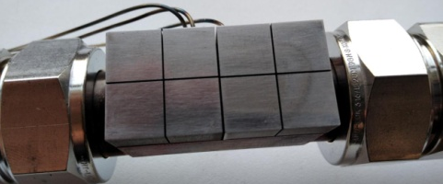(b)
Figure 1 - Cooled tungsten divertor module during (a) and after (b) irradiation in the PLM
Plasma tests were carried out within the framework of project 223 EOTP-UTP of Rosatom State Corporation, the analysis of materials was carried out with the support of the Ministry of Science and Higher Education of the Russian Federation (FSWF-2020-0023, the assessment of radiation effects was carried out with the support of the RFBR grant 19-29-02020.
References
- Budaev V. P. VANT, ser. Thermonuclear synthesis. - 2015. - Vol. 38, No. 4. - P. 5
- Budaev V. P. et al. VANT ser. Thermonuclear fusion. - 2017. - Vol. 40, No. 3. - P. 35

*) abstracts of this report in Russian

