THE FIRST RESULTS OF PLASMA DENSITY PREDICTION USING NEURAL NETWORKS FOR TYPICAL DISCHARGES OF THE T-11M TOKAMAK *)
DOI: 10.34854/ICPAF.2022.49.1.177
Leshov N.V., Mirnov S.V., Shcherbak A.N.
JSC "SRC RF TRINITI", Troitsk, Russia, leshov@triniti.ru
The paper investigates the possibility of using an artificial neural network (ANN) to predict the electron density in typical discharges of the T-11M tokamak. A further comparison of the predicted density for specific discharge parameters and the actually measured density will make it possible to speak about some features of the plasma behavior, such as, the transition to other regimes (H-mode), the penetration of impurities into the center of the plasma column, etc.
Previously, other facilities have already demonstrated the successful use of ANNs to predict plasma disruptions [1] and to simulate various plasma parameters [2, 3], thus proving that ANNs can describe the dependency between discharge parameters (input data) and plasma parameters (output data).
To train the ANN, we used the data of the experimental campaign of 2016 (approximately 851 discharges). Some of the main parameters that directly affect the plasma density are the amount and time scenario of gas puffing into the vacuum chamber of the tokamak during the plasma discharge. Therefore, the input data for training the ANN are the opening time of the gas valve, the duration of its operation, and the gas pressure before the valves. The output is a "raw" electron density signal measured with an interferometer.
Figure 1 shows an example of a comparison of the average electron density for a central chord
(-1 cm) during the discharge (# 40246), calculated from the predicted and measured raw signals of the interferometer. In this case, the predicted plasma density corresponds to the typical T-11M discharge for the selected discharge parameters, while the actually measured plasma density demonstrates a spontaneous transition to the H-mode.
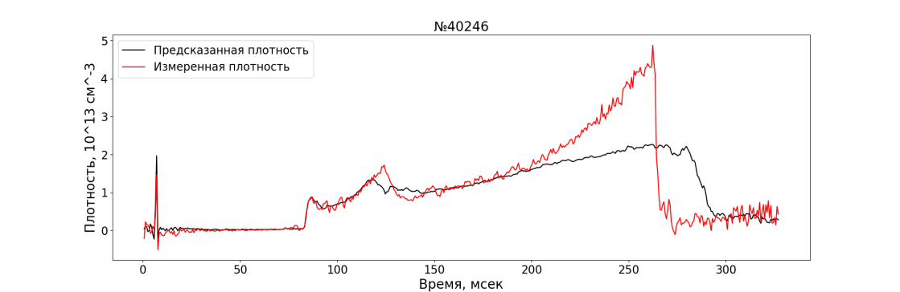
Fig. 1. The time evolution of the predicted and measured average electron density during the discharge (# 40246)
In the future, it is planned to use a more complex model, expand the data, which will make it possible to take into account other discharge parameters that affect the plasma density, as well as to ensure the variability of the condition of the tokamak vacuum chamber (the condition of the vacuum chamber wall, the presence of intrachamber devices, such as limiters, injectors, etc.).
References
- Zheng W. et al. Nuclear Fusion, 2018, 58, 056016.
- Hui L. I. et al. Plasma Science and Technology, 2021, 23, 115102.
- Yang B. et al. Plasma Physics and Controlled Fusion, 2020, 62, 075004.

*) abstracts of this report in Russian

