About spatial distribution of plasma potential long-range correlations in the tj-ii stellarator *)
DOI: 10.34854/ICPAF.2022.49.1.040
^{1,2}Sarancha G.A., ^{1,2,3}Melnikov A.V., ¹Eliseev L.G., ¹Khabanov F.O., ^{1,4}Kharchev N.K.
¹NRC “Kurchatov Insititute”, nrcki@nrcki.ru
²Moscow Institute of Physics and Technology (NRU), info@mipt.ru
³National Research Nuclear University “MEPhI”, info@mephi.ru
⁴Prokhorov General Physics Institute, office@gpi.ru
Zonal flows play an important role in the toroidal plasma confinement studies nowadays, since they are considered to be a mechanism for the plasma turbulence self-regulation, which converts radial particles and energy losses into torsional oscillations [1]. GAM (geodesic acoustic mode) is a high-frequency branch of zonal flows; it is studied on many tokamaks and stellarators [2, 3, 4]. The low-frequency branch, or actually zonal flows, manifest themselves as a low-frequency continuous spectrum of electric potential oscillations, symmetric in the toroidal and poloidal directions (m = n = 0). The report is dedicated to the such oscillations study in the TJ-II stellarator plasma (Madrid, Spain) using the double heavy ion beam probe diagnostics (HIBP).
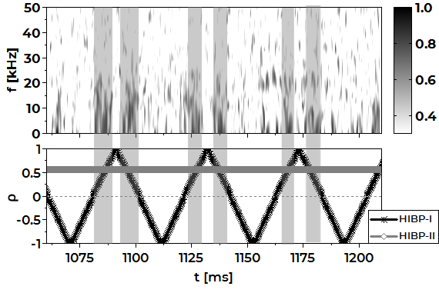
HIBP is a local diagnostic that allows measuring the plasma electric potential both in the plasma edge and core. The HIBP diagnostic complex of the TJ-II stellarator is equipped with two probe beams located at a 90° toroidal angle to each other (the measurement points are at a distance of about 2.5 m), and allows correlation measurements of electric potential oscillations. Each beam is capable to operate in the measurement mode both at a point and a wide scanning over the entire plasma column from the low field side to the high field side.
Fig. 1 Spectrogram of the quadratic coherence coefficient between plasma potential signals of HIBP-I and HIBP-II (top), the position of the beams measurement points (bottom). The vertical gray stripes mark the time intervals with a noticeably high coherence coefficient (> 0.4).
The report presents the results of the electric potential long-range correlations distribution study over the plasma column cross-section in various stellarator operating modes (for example, Fig. 1).
The work is supported by the RSF, project 19-12-00312.
References
- A. Fujisawa, A review of zonal flow experiments // Nucl. Fusion 49 013001 (2008);
- Melnikov A.V. et al, Heavy ion beam probing—diagnostics to study potential and turbulence in toroidal plasmas // Nucl. Fusion 57 072004 (2017);
- Y.Xu et al. Long-distance correlation and zonal flow structures induced by mean E×B shear flows in the biasing H-mode at TEXTOR // Phys. Plasmas 16 110704 (2009);
- A.A. Belokurov, et al. Geodesic Acoustic Mode Temporal Parameters Effect on the LH-Transition Initiation Possibility in TUMAN-3M Tokamak // Tech. Phys. Let. 45 783–785 (2019)

*) abstracts of this report in Russian

