Hybrid “fusion-fission” reactor facility: CFD-research *)
DOI: 10.34854/ICPAF.2022.49.1.058
¹Bedenko S., ¹Lutsik I., ¹Polozkov S., ²Matyushin A., ³Arzhannikov A., ³Prikhodko V., ⁴Modestov D., ⁴Shmakov V.
¹National Research Tomsk Polytechnic University, Tomsk, Russia, tpu@tpu.ru
²OKB Gidropress, Podolsk, Russia, grpress@grpress.podolsk.ru
³Budker Institute of Nuclear Physics SB RAS, Novosibirsk, Russia, inp@inp.nsk.su
⁴Russian Federal Nuclear Center – Zababakhin Institute of Applied Physics,Snezhinsk,
Russia, vniitf@vniitf.ru
Earlier, for the study of three-dimensional neutron fields and heat release in a hybrid fusion-fission facility, we developed computational models of a blanket and a plasma neutron source (PNS). Our performed studies made it possible to increase the “brightness” of the D-T neutron source [1], to analyze the nuclear and technological safety of the system when operating in a repetitively pulsed mode [2]. As a result of the simulation, it was found that when the PNS in the mode of constant emission of DT neutrons creates a flux at a level of 2.6×10¹⁷ n×s⁻¹, in the blanket part of the installation at k_{eff} = 0.95, this flux will increase to a value of ~ 10²⁰ n×s⁻¹. In the case of using a pulse-periodic mode of operation of the installation, such a flow inevitably leads to the formation of inhomogeneity of the energy release field in the blanket part. This circumstance leads to the formation of temperature field gradients, which can lead to a decrease in the service life of the fuel part of the blanket in a pulse-periodic mode.
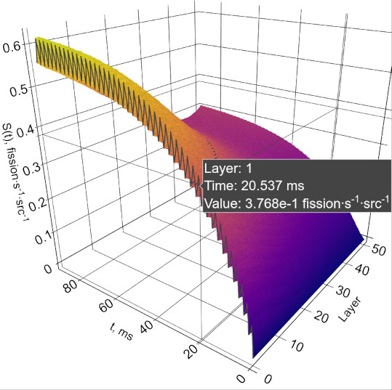 | 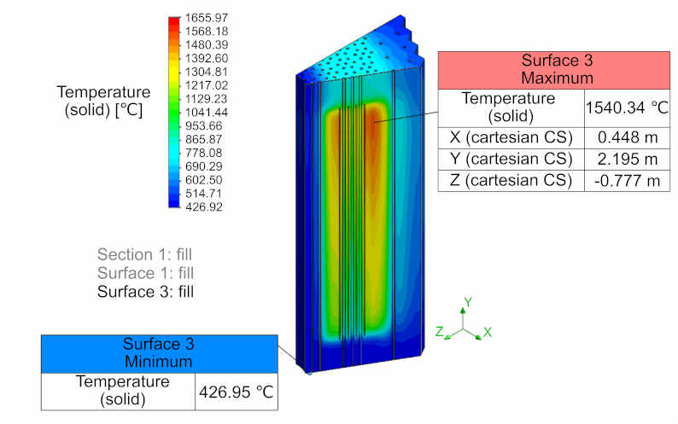
(a) | (b)
Fig. 1. Results of modeling (a) the intensity of nuclear fission in the volume of the first blanket layer adjacent to the PNS and (b) the energy release field in the blanket sector
In this study, a CFD model (Computational Fluid Dynamics Model) of a blanket was created to level the arising offsets of the radial and axial energy release fields. The results of the study (see Fig. 1) made it possible to adjust the operation of the PNS (1) for safe operation start of the facility and (2) for maneuvering power in the long-term operation mode.
The reported study was funded by RFBR, project number 19-29-02005.
References
- Prikhodko V.V. and Arzhannikov A.V. Simulations of fusion neutron source based on the axially symmetric mirror trap for the thorium hybrid reactor. J. Phys.: Conf. Ser., 2020 1647 012004.
- Shamanin I.V., et al. Neutron data field in a fission reactor core with fusion neutron source at pulse-periodic operation. J. Phys.: Conf. Ser., 2020, 1647 012007.

*) abstracts of this report in Russian

