DEVELOPMENT of the charge exchange neutral particle analyzer for the mephist tokamak *)
DOI: 10.34854/ICPAF.2022.49.1.060
Efimov N., Sinelnikov D., Bulgadaryan D.
NRNU MEPhI, Moscow, Russia, NEEfimov@mephi.ru
In fusion devices, ion temperature is one of the most crucial factors characterizing plasma performance. Charge-exchange neutral particles’ energy spectrum analysis is a widespread technique for the determination of ion temperature. Such spectra might be obtained by ionization of neutral particles and subsequent spatial separation in electric/magnetic fields.
MEPhIST is a small educational research spheromak (a = 13 cm, R=25 cm) with a toroidal field up to 0,8 T, plasma current 8 kA and expected ion temperature 200 eV [1]. In such small machines for the energy spectra of charge exchange neutrals measurements a combination of a gas stripping cell and an energy analyzer with plane-parallel plates and a decelerating field can be used [2].
In this paper we present the design of a 7-channel charge exchange neutral particle analyzer for the MEPhIST tokamak and its calibration in the energy range of 0,5 – 5 keV. One of the unique features of this diagnostics is the use of the sulfur hexafluoride (SF₆) as the stripping gas. It was shown (fig. 1), that for SF₆ the maximum of the stripping efficiency lies in a lower pressure range compared to more commonly used stripping gases (H₂, N₂). In addition, it allows achieving a higher stripping efficiency of hydrogen atoms (up to 0,1). The dependence of the stripping coefficient by SF₆ gas on the energy of incident hydrogen atoms is obtained. The energy resolution of the energy analyzer channels is also determined.

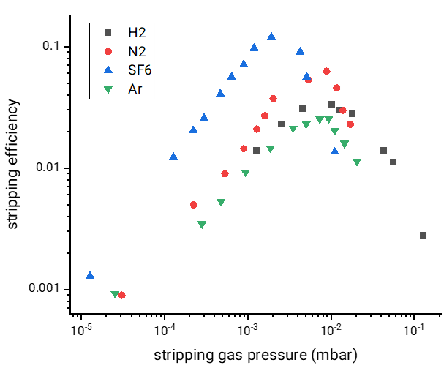
Figure 1. Stripping efficiency of various gases for 3 keV hydrogen atoms.
References
- Kirneva N. A.., Vorobjev G. M., Ganin S. A. etc. Working area of the MEPhIST tokamak: preliminar estimation // Problems of atomic science and technology, ser. thermonuclear fusion, 2020, 43., № 3, p. 90–100.
- Ajay K., Pandya S. P. & Aggarwal S. Experimental Results of Core Ion Temperature and Neutral Density Measurements on ADITYA Tokamak using Four Channels Neutral Particle Analyzer // Journal of Fusion Energy, 2020, 39, 3, p. 111–121.

*) abstracts of this report in Russian

