Study of regimes with improved energy confinement in tokamak plasmas *)
DOI: 10.34854/ICPAF.2022.49.1.037
^{1,2}Kasyanova N.V., ¹Razumova K.A., ¹Andreev V.F.
¹NRC “Kurchatov Institute”, Moscow, Russia, Kasyanova_NV@nrcki.ru
²Moscow Institute of Physics and Technology, Dolgoprudny, Russia
To date, a large amount of experimental data has been obtained indicating that Fick's relations were not applicable to describe transport phenomena in turbulent tokamak plasma since they expressed heat and particle fluxes in terms of local plasma parameters and their gradients. As experimentally known the normalized pressure profile is independent of the plasma parameters, heating power and the size of tokamaks [1]. Therefore to describe the plasma energy balance it is necessary to use an equation that would preserve the normalized pressure profile.
In [2] an approach of nonequilibrium thermodynamics is proposed to describe the evolution of plasma. Within the framework of this approach the relaxation dynamics of the system at small deviations from the equilibrium state is described by an equation similar to the Smolukhovsky equation with the thermal conductivity coefficient κ=θ(χ₀+χ₁) [2]. If the pressure profile is close to the self-consistent profile then the coefficient κ=θχ₀ is minimal (i.e. χ₁=0), the stored energy reaches the maximum value. In the opposite case an additional heat flux occurs that aimed at approaching the pressure profile closer to the self-consistent profile and the thermal conductivity coefficient increases κ=θ(χ₀+χ₁).
The saturated ohmic confinement (SOC) regimes, in which the maximum stored plasma energy is reached, correspond to the minimum deviation of the pressure profile from the self-consistent profile. Therefore, the analysis of SOC regimes allows us to estimate the thermal conductivity coefficient χ₀. In experiments carried out in the T-10 tokamak it is shown that within the experimental error the coefficient χ₀ is radially constant and its value is independent of the plasma heating power. Using the found coefficient χ₀ we estimated maximum stored energy for DIII-D tokamaks (in hybrid mode, I- and H-mode, super H-mode); JET (in hybrid mode); ASDEX Upgrade (in hybrid mode and I-mode); JT-60U and KSTAR (in hybrid modes). It is shown that the experimentally measured stored plasma energy is close to the calculated maximum values or does not exceed them (Fig. 1). The energy confinement time is estimated for two basic operational scenarios of ITER.
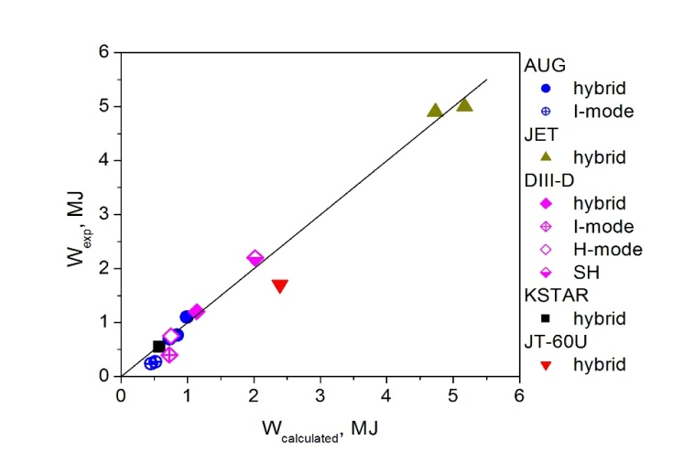
Figure. 1. Calculated and experimentally measured stored plasma energy.
References
- Razumova K.A., et al Nucl. Fusion. 49 (2009) 065011
- Dyabilin K.S. and Razumova K.A. // Plasma Phys. Rep. 2015. V. 41. P. 685

*) abstracts of this report in Russian

