HOT ION spectra in DEMO-FNS
Dnestrovskiy A.Yu. and ¹Goncharov P.R.
National Research Centre Kurchatov Institute, Moscow, Russia
¹Peter the Great Saint Petersburg Polytechnic University, Saint Petersburg, Russia
Distributions of fast ions by energy in the plasma carry an information about the heat power, current drive (the asymmetry of the spectra in the direction of the hot ion velocity) and instabilities growth rates. This work is devoted to calculations of fast particles spectra from neutral beam injection. The calculations are carried out using the semi-analytical approach to the distribution function of fast ions [1] in addition to the numerical calculations by the Monte Carlo code NUBEAM [2]. The geometry of the input neutral beam is taken for DEMO-FNS device [3] with different major radius. Numerical and semi-analytical approaches are considered together on a common transport platform ASTRA, allowing to specify the details of the equilibrium plasma column in different regimes. The results of the comparison calculations of the spectra of the fast deuterium ions from the neutral deuterium injection in DEMO-FNS is shown in the figure for the two approaches. Semi-analytical method (dashed line) includes the description of the transition between hot and thermal components accounting the particle conservation condition. While the Monte Carlo code specifies the loss of fast particles when they reach the energy value 3/2 T_{i} on a given magnetic surface. The good agreement between spectra is obtained in the mid-radius area. The discrepancy between two approaches in the central plasma can be caused by the drift across the magnetic surface which is taken into account in the Monte Carlo code.
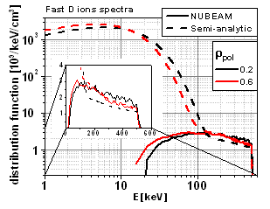
References
- P.R. Goncharov, B.V. Kuteev, T. Ozaki, S. Sudo Analytical and semianalytical solutions to the kinetic equation with Coulomb collision term and a monoenergetic source function, Phys. Plasmas 17 (2010) 112313
- Pankin A, Mccune D, Andre R, Bateman G and Kritz A 2004 The tokamak Monte Carlo fast ion module NUBEAM in the National Transport Code Collaboration library, Comp. Phys. Comm. 159 (2004) 157-184
- Dnestrovskij A.Yu. et al. 2015 Integrated modelling of DEMO-FNS current ramp up scenario and steady state regime Nucl. Fusion 55 063007

