Conceptual design of low aspect ratio superconducting tokamak with strong magnetic field (T15-S)
Ivanov D.P., Melnikov A.V., and Korobov K.V.
National Research Centre Kurchatov Institute, Moscow, Russia, denis.ivanov30@mail.ru
The Tokamak Department of the Kurchatov Institute is presently creating the D-shaped T-15 tokamak with water cooled copper coils [1, 2]. This machine has following parameters: R = 1.5 m, a = 0.67 m, B =2 T, I_{pl} = 2 MA and plasmas with an elongation <2 and triangularity <0.4, pulse duration <10 s.
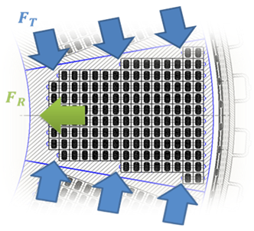
The present paper is considering the next stage of the upgrade of this machine to the superconducting one with basically the same geometry and shape. The estimations show the possibility to make a toroidal magnet with aspect ratio A = 2.2, magnetic field on the plasma axis B₀ = 5 T, maximum magnetic field B_{m} = 12.5 T. Such increase in B₀ provides the possibility to get plasma current up to 5 MA. The design for the toroidal magnet suggests the SC-winding that withstand the main part of mechanical loads on the coil and thick wall conduit that works together with coil case (figure). Toroidal coil consists of three layers with HTSC inside, Nb₃Sn in the middle and NbTi in outer layer and transverse flow cooling. This new project with its favorable combination of low aspect ratio A and really high magnetic field B is beneficial for the plasma performance and the long-pulse discharge via high fraction of bootstrap current. The main research topics foreseen are the features of the confinement at high B and low A and steady-state operation. In addition, this project will also serve as a test-stand, which is absolutely necessary для сооружения магнита для for the Fusion Neutron Source SC magnet design, mastering and tests.
Figure. Stresses in toroidal field coil at В₀ = 5 Т: F_{R} = 3.7 MH, σ = 50 MPa, F_{T} = 185 MH, σ = 150 MPa, F_{Z} = 15 MH, σ = 360 MPa.
Refernces
- Azizov E. et al. 25th Fusion Energy Conf. St. Petersburg, 2014. Rep FIP/3-2.
- Melnikov A.V. et al., Fusion Eng. Design 2015, v. 96-97, p.306.

