INVESTIGATION OF SYNTHETIC JET FORMED BY AN MHD ACTUATOR
Karmazkiy P.E., ¹Kazanskiy P.N., ¹Moralev I.A., ¹Firsov A.A. and ¹Efimov A.V.
Moscow Power Engineering Institute, Moscow, Russia knispel.kurt@gmail.com
¹Joint Institute for High Temperatures, Russian Academy of Sciences, Moscow, Russia,
morler@mail.ru
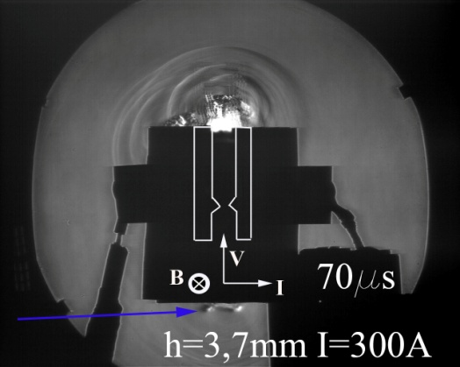
This study is devoted to a new type of actuator based on the creation of jets with a zero mass consumption over the period of its work (synthetic jet) [1]. Inside the channel of actuator tungsten electrodes and magnetic field with induction B = 1.2 T are placed. The gas inside the channel is set in motion by the thermal expansion and the action of the Lorentz force. The arc current reaches up to 300 A. Since the energy input is asymmetric, it is possible to design the actuator channel open at both ends. This reduces the relaxation time of the actuator after the arc is turned off, and thus increase the operating frequency in comparison with sparkjet actuator device without a magnetic field [2]. Asymmetric jet created near one of the channel outputs, was investigated by the shadow method (figure) and by PIV. It has been found that the speed of the jet near the nozzle exit is 450 m/s. In this case the front edge of the jet is moving at a speed of 200 m/s.
Figure. Shadow picture of synthetic jet through 70 µs after the breakdown discharge.
References
- M. Jabbal, Int. J. Heat and Fluid Flow, Vol. 29, 2008, pp. 119-130.
- Di Jina, Chinese Journal of Aeronautics, Vol 28, Is 1, Feb 2015, P66–76.

