investigation OF ARC DISCHARGE IN MAGNETIC FIELD NEAR the WALL at high Reynolds numbers
Karmazkiy R.E., ¹Kazanskiy P.N. and ¹Moralev I.A.
Moscow Power Engineering Institute, Moscow, Russia knispel.kurt@gmail.com
¹Joint Institute for High Temperatures, Russian Academy of Sciences, Moscow, Russia,
morler@mail.ru
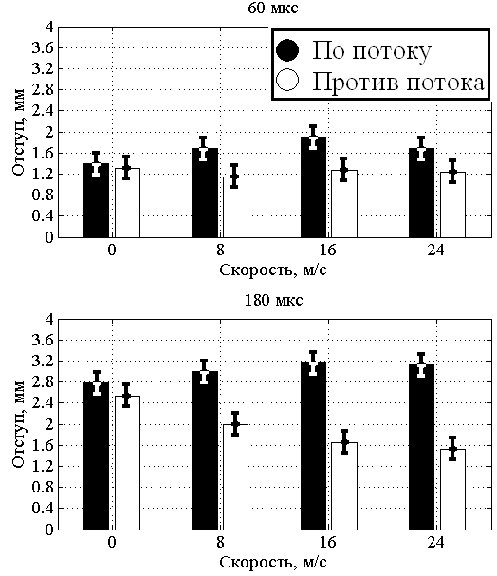
Plasma actuators are used to control the boundary layer, flow separation and noise currents. Today the most common plasma actuators are actuators on the basis of the dielectric barrier discharge. These actuators have a very low thrust and energy efficiency to control high-speed flows. It is therefore a promising development of the actuators that control the flow of heat using electric discharge, and the Lorentz force. MHD actuator is a pair of electrodes placed in a magnetic field, between which a pulsed arc is implemented. The arc discharge in a magnetic field generates a stream on its border, which can be represented as a superposition of thermal expansion and a pair of vortexes. Kinematics of the arc channel in the external flow is determined by the interaction of disturbances created by actuator, with the boundary layer. In this study we investigated the influence of the external flow on the dynamics of the movement of the arc discharge in a magnetic field. External flow velocity in this study did not exceed 24 m/s. On the surface of the working chamber of a wind tunnel an arc is ignited. The camera of the wind tunnel is placed in a uniform magnetic field with induction B = 0.44 T. Discharge current varies from 18 to 70 A. The duration of the discharge pulse is about 500 ms. A shooting of the arc motion process is carried out by a high-speed camera with a recording frequency of 17 kHz. We have obtained the relations between the indentation from the wall of the arc and the speed of the arc movement and the speed and direction of the incoming flow. It has been found that the arc extends from the channel wall surface when moving downstream and is pressed against the surface of the wall when moving upstream (figure). Presumably this is due to the interaction of the induced pair of vortexes at the outer arc region with the wall and the outer flow in the boundary layer.
Figure: Diagram of the dependence of the indentation of the arc on the speed and direction of the incoming flow.

