Confinement OF SPHERICAL PLASMA by means of fields generated by magnetic dynamo
A.G. Oreshko and T.B. Mavlyudov
¹Moscow Aviation Institute, Moscow, Russia, A.G.Oreshko@gmail.com,
²Research Institute of Scientific Instruments, Lytkarino, Moscow oblast, Russia,
Mavludov@gmail.com
It is known that the optimal configuration of magnetic field for plasma confinement is configuration with a minimum magnetic field strength in the center of the chamber. Charged particles in this case can not move in the area of radially increasing magnetic field. The magnetic field with a minimum induction in the center of the chamber can be created using superconducting magnetic systems that can operate only at ultra low temperatures. Significant problems appear with placing the elements of the super-conducting magnetic systems in the area of hot first reactor wall.
Configurations with a minimum induction exists in stars in the form of the poloidal magnetic field. In stars there is a process of self-generation of such field which provides a minimum of magnetic induction in the central region – in the core of the star due to the magnetic dynamo. Generating of self magnetic field also takes place in ball lightning [1]. Therefore, a particular interest presents the development of reactors of spheromak-type in which the fusion reaction is planned to carry out in a spherically symmetric plasma.
Pulse toroidal magnetic field was obtained by electric explosion of copper spirals [2]. In MHD methods and in attempts to explain the magnetic dynamo it is considered that it is created by plasma with high conductivity [3]. However, good results at the Center of the experimental research of magnetic dynamo were not obtained.
To obtain a magnetic dynamo is possible only in presence of a strong closed circular current in plasma. In experiments carried out at the modernized generator "Prometheus" at atmospheric pressure were obtained spherical plasma formations of maximum diameter of 1 m. The maximum energy in capacitive storage was 60 kJ.

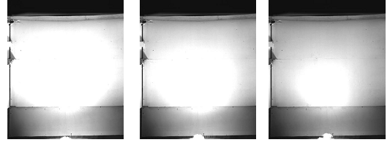

References
- Oreshko A.G. An investigation of the generation and properties of laboratory-produced ball lightning. J. Plasma Physics, 2015, v.81, N3, p.18.
- Vlasov A.N., Ryabov, M.V., Burobin M.A. et al., Vestnik of Ryazan state radioengineering university, Ryazan, 2013, N1 (43), p. 90-94.
- Spence E. J., Reuter K., Forest C.B.. A spherical plasma dynamo experiment. The Astrophy-sical Journal, 2009, v.700, pp.470–478.

