Spectral analysis of GAMs and broadband plasma OSCILLAtions in T-10 tokamak
A.V. Melnikov¹, L.G. Eliseev¹, S.E. Lysenko¹, and M.V. Ufimtsev²
¹National Research Centre Kurchatov Institute, Moscow, Russia, Lysenko_SE@nrcki.ru
²Lomonosov Moscow State University, Moscow, Russia
Geodesic acoustic modes (GAMs) are the high-frequency counterpart of zonal flows. They are considered as one of possible mechanisms of the broadband turbulence self-regulation [1]. GAMs on the circular tokamak T-10 (B = 1.5−2.5 T, R = 1.5 m, a = 0.3 m) were investigated by heavy ion beam probing [2]. It was shown that the frequency of plasma potential ϕ oscillations, generated by GAM is constant along the minor radius [3]. So, GAMs on the potential are seen as the global eigenmode of plasma oscillations. However, the GAM frequency is proportional to the sound speed, or the square root of the electron temperature (in the one-fluid approximation),
f ~ √(T_{е}), where T_{е} is taken on the radius ρ = r/a = 0.75. If we take into account the ion temperature, then ρ = 0.9 [4].
In the presented report we performed the spectral analysis of broadband oscillation of potential and density n. At the plasma edge, ρ > 0.8, in the spectrum of potential oscillations we see both the narrow quasimonochromatic GAM dominated peak with the frequency f_{GAM} ~ 14 kHz and the noticeable peak of quasicoherent oscillations with f_{QC} ~ 40-100 kHz, which is rather wide, FWHM Δf_{QC} ~ 30 kHz (fig. 1). This peak is seen in the spectrum of density oscillations, obtained from oscillations of the total current of probing heavy ions. Bi-spectral analysis of potential oscillations shows the presence of statistically significant auto-bicoherency at the GAM frequency for the triplet (ϕ, ϕ, ϕ) at the edge, ρ > 0.8. Bi-coherency exceeds the noise value over the broad frequency range up to 250 kHz. This means an existence of three-wave interplay between the GAM and broadband turbulence. Note that maximal values of bi-coherency correspond to the quasicoherent peak of frequencies 70-100 kHz. This points out to the oscillations of energy exchange between this peak and GAMs. Noticeable bi-coherency at the GAM frequency is seen for the auto-bicoherency (n, n, n), but mainly for the cross-bicoherency (ϕ, n , n), fig. 2. These data means that the origin of GAM on Т-10 is the broadband turbulence.
The work was funded by Russian Scientific Foundation project 14-02-00193.
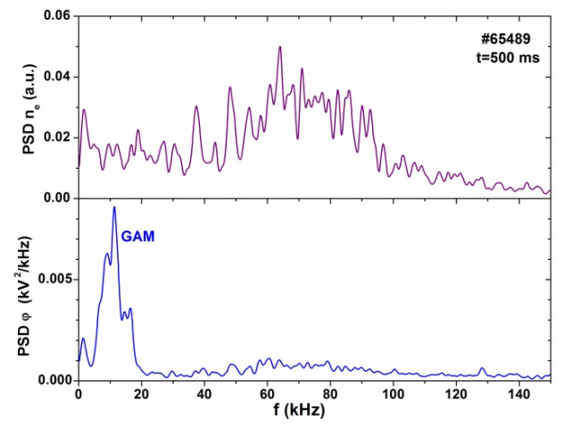
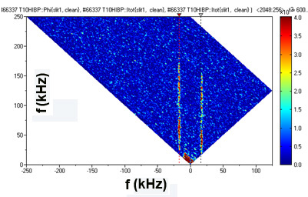

Fig. 1. Spectra of density and potential oscillations Fig. 2. Cross-bicoherncy of potential and density
References
- Fujisawa A., et al., Nucl. Fusion (2007) 47, S718.
- Melnikov A.V., et al., Problems of Atomic Sci. Tech., ser. Plasma Phys. (2013) No 1(83) 30.
- Melnikov A.V., et al., JETPh Letters (2015) 100, 555.
- Melnikov A.V., et al. Nucl. Fusion (2015) 55, 063001.

