spectral characteristics of extended atmospheric discharge
A.A. Letunov¹, A.V. Oginov², A.A. Rodionov², and K.V. Shpakov²
¹Prokhorov Institute of General Physics, Russian Academy of Sciences, Moscow, Russia,
let@fpl.gpi.ru
²Lebedev Physical Institute, Russian Academy of Sciences, Moscow, Russia
During an extensive discharge developing in air in the interelectrode space of 500–600 mm in length, the radiation in the visible spectral range carries information about the parameters of streamer-leader stage of the discharge, the discharge channel interaction with the electrode material, and the relaxation stage after the decay of the plasma channel of the discharge current.
Studies of spark discharges were carried out at the ERG facility of Lebedev Physical Institute of the Russian Academy of Sciences (1 MB, 60 kJ, 150 ns rise time) [1].
For registration of emission spectra, we used AvaSpec 3648 spectrometer with a resolution of 0.3 nm in the wavelength range from 370 to 920 nm and AvaSpec 2048 with a resolution of 1.3 nm in the wavelength range from 185 to 750 nm. Emission was collected integrally from the cross-sectional area which is substantially distant from both electrodes.
The spectra of the discharge taken by AvaSpec 2048 in two successive time intervals are shown below. The first includes a streamer-leader stage and a certain part of the relaxation stage, the second includes the rest of relaxation stage.

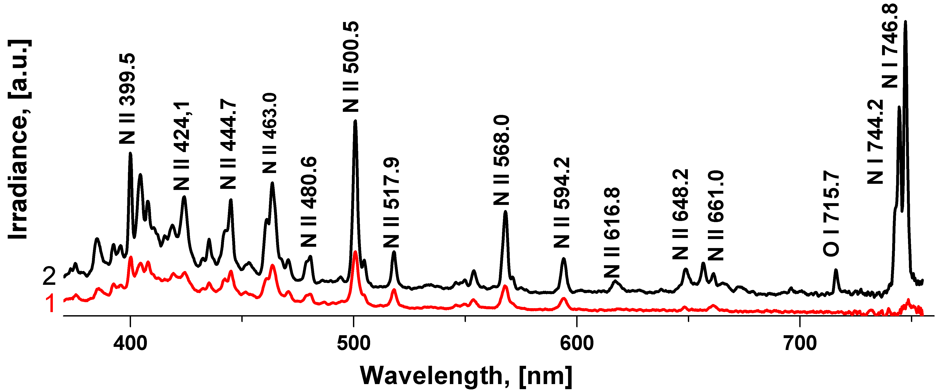
These spectra are well supplemented by those taken by the AvaSpec 3648 spectrometer having better resolution and a red limit of 920 nm. As a whole, the spectra are similar to those of the natural linear lightning obtained in [2]. The lines of N II ion in the short wavelength range and the lines of atomic nitrogen and oxygen in the range of more than 700 nm can be identified in it.
Under the assumption of collisional mechanism of line broadening, the lines of N II ion can be fitted by the Lorentz line profile with a half-width ~2 nm, the spectral resolution being 0.3 nm. This corresponds to collisions frequency of ~10¹² Hz. The widths of atomic lines are shorter.
Low temporal resolution of spectrometers is to some extent complemented by the photomultipliers data measured in five spectral regions singled out by glass filters.
This work was supported by the RFBR grants 13-08-01379, 14-08-31397.
References
- A.V. Agafonov, V.A. Bogachenkov, A.V. Oginov, A.S. Rusetsky, V.A. Ryabov, A.P. Chubenko, K.V. Shpakov. Book of Abstracts of XLII International Conference on Plasma Physics and CF, February 9 – 13, 2015, Zvenigorod, p. 210.
- Jianyong Cen, Ping Yuan and Simin Xue. Observation of the Optical and Spectral Characteristics of Ball Lightning, Phys. Rev. Lett., 112, 035001 (2014).

