On the efficacy of sterilization by non-thermal plasma jets of DC and barrier discharges at atmospheric pressure
Yu.S. Akishev^{1,2}, A.A. Balakirev¹, V.B. Karalnik¹, M.A. Medvedev³, A.V. Petryakov¹, N.I. Trushkin¹, A.G. Shafikov³, A.A. Kirillov⁴, A.V. Pavlova⁴, L.V. Simonchik⁴, N.V. Dudchik⁵, and O.E. Nezhvinskaya⁵
¹Troitsk Institute for Innovation and Fusion Research, Troitsk, Moscow oblast, Russia,
shurik_na@bk.ru
²Moscow Engineering Physics Institute, Moscow, Russia, akishev@triniti.ru
³Moscow Institute of Physics and Technology, Dolgoprudny, Moscow Oblast, Russia,
ayrat.shafikov@phystech.edu
⁴Stepanov Institute of Physics, National Academy of Sciences of Belarus,Minsk, Belarus
⁵Republican unitary enterprise Scientific Practical Centre of Hygiene, Minsk, Belarus
The report contains the experimental results on sterilization of the microorganisms (which??) by non-thermal plasma jets generated by steady-state DC glow discharge and dielectric barrier discharge at atmospheric pressure. Plasma forming gases are N₂, Ar, He and their mixtures with O₂. The results obtained allow us to split the contribution to biocide effect of different types of reactive agents such as UV radiation, the charged particles and ORS and NRS. This information is of great interest for the development of plasma sterilization mechanism that is important for optimization of plasma sources used in biomedicine, plasma medicine, etc.
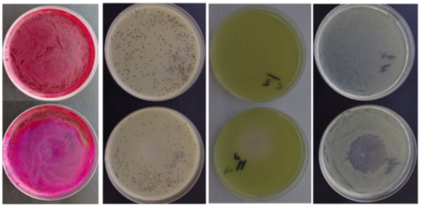
a) b) c) d)
Fig. 1. Treatment of microorganisms consortium by an air glow discharge plasma jet. Treatment time is 10 minutes. Upper row – control samples, lower row – treated samples of a) E. coli,
b) S. aureus, c) P. aeruginosa, d) consortium CG/N-1.
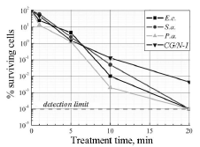
Fig. 2. Inactivation curves of individual microorganisms and their consortium in result of plasma jet exposure.

