Nonlinear waves in two-fluid magnetohydrodynamics in the presence of a longitudinal magnetic field

M.B. Gavrikov and V.V. Savelyev

Keldysh Institute of Applied Mathematics, Russian Academy of Sciences, Moscow, Russia,  
[nadya_p@cognitive.ru](mailto:nadya_p@cognitive.ru), [ssvvvv@rambler.ru](mailto:ssvvvv@rambler.ru)

The report is devoted to investigation of non-linear waves in two-fluid magnetohydrodynamic for the case of ideal, quasi-neutral and cold plasma in the presence of longitudinal magnetic field. The analysis of the non-linear waves is based on the conservation laws of mass, momentum, energy and the laws of electrodynamics. The studied waves are solutions of equations depending of  in the combination , were is the constant unit vector, determining the direction of wave propagation and  is a constant phase velocity of wave. It is shown that for non-linear waves is a specified longitudinal magnetic field and is the solution of the equation of the second order

 (1)

were  - are arbitrary constants. The remaining wave parameters are calculated by vector . For example .

In the Lagrangian variable  related with  by relation , the equation (1) reduces to the equation of motion of a material point in the plane under the action of forces with cubic nonlinearity. The arising Hamiltonian system with  is completely integrable. Among the solutions of this Hamiltonian system, the solitary wave in the form of wave packet oscillations is of particular interest (fig). The magnetic field in the “hump” of the pack may be much more then longitudinal magnetic field .

In the work on the basic of numerical solution of one-dimensional equations of two-fluid MHD the “collisions” of different solitary waves were investigated. It turned out that the interaction of these waves looks like an elastic “collision” of solitons. More simple case of non-linear waves in the absence of longitudinal magnetic field is considered in [1].

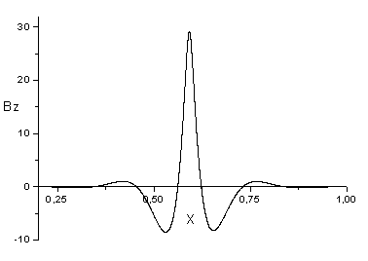

References

1. Гавриков М.Б., Таюрский А.А., Савельев В.В., Солитоны в двужидкостной МГД с учетом инерции электронов, Изв. вузов, Прикладная нелинейная динамика, т.18, N 4, 2010, с.132-147 (in Russian).