On UV, visible and IR spectra emitted from non-thermal plasma jets of DC and barrier discharges at atmospheric pressure
Yu.S. Akishev^{1,2}, A.A. Balakirev¹, V.B. Karalnik¹, M.A. Medvedev³, A.V. Petryakov¹, N.I. Trushkin¹, A.G. Shafikov³, A.A. Kirillov⁴, A.V. Pavlova⁴, and L.V. Simonchik⁴
¹Troitsk Institute for Innovation and Fusion Research, Troitsk, Moscow oblast, Russia,
shurik_na@bk.ru
²Moscow Engineering Physics Institute, Moscow, Russia, akishev@triniti.ru
³Moscow Institute of Physics and Technology, Dolgoprudny, Moscow Oblast, Russia,
ayrat.shafikov@phystech.edu
⁴Stepanov Institute of Physics, National Academy of Sciences of Belarus,Minsk, Belarus
The report contains the experimental results on a spatial distribution of UV, visible and IR spectra along non-thermal plasma jets generated by steady-state DC glow discharge and dielectric barrier discharge at atmospheric pressure. Plasma forming gases are N₂, Ar, He and their mixtures with O₂. Plasma jets enter the ambient air at atmospheric pressure. Variable parameter is a gas flow velocity at the outlet of plasma source. The results obtained allow to determine the distribution along plasma jet of both the gas temperature and the composition of reactive species produced by non-thermal plasma. This information is of great interest for the development of mechanism of plasma species generation and for practical applications (surface modification, biomedicine, etc) based on the usage of non-thermal plasma jets at atmospheric pressure.
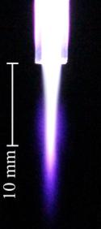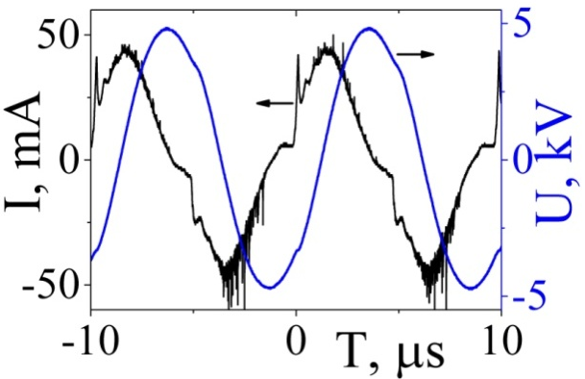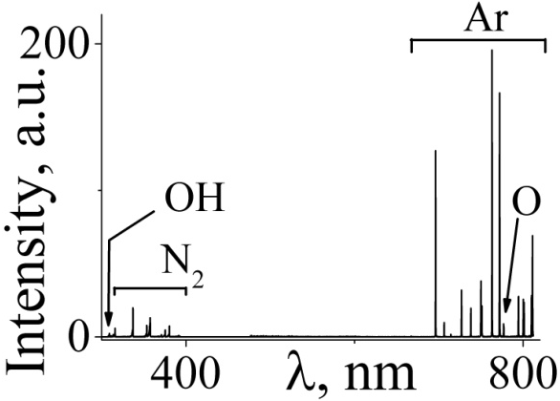
a) b) c)
Fig. 1. Plasma jet photos (side-on view) for dielectric barrier discharge jet (a), waveforms of current and voltage of DBD (b), emission spectrum of the plasma generated in argon at the outlet of the discharge zone (c).
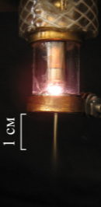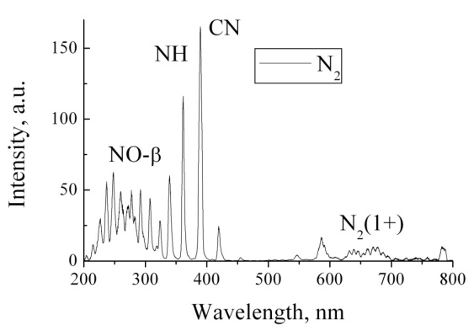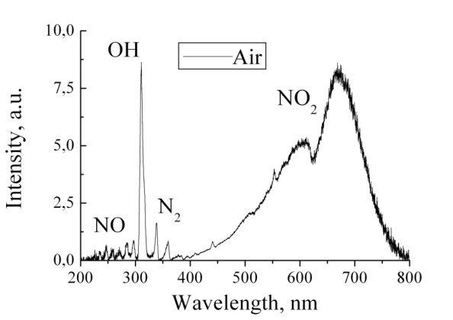
a) b) c)
Fig. 2. Plasma jet photos (side-on view) for glow DC discharge jet (a), emission spectrum of the plasma generated in nitrogen (b) and air (c) at the outlet of the discharge zone.

