STUDIES OF THE PLASMA OF Z-PINCH INITIATED BY ELECTRON BEAM
A.A. Drozdovsky¹, A.V. Bogdanov¹, R.O. Gavrilin¹, A.A. Golubev^{1,2}, S.A. Drozdovsky¹, I.V. Roudskoy¹, S.M. Savin¹, P.V. Sasorov³, and V.V. Yanenko^{1,2}
¹Institute of Theoretical and Experimental Physics, Moscow, Russia
²Moscow Engineering Physics Institute, Moscow, Russia
³Keldysh Institute of Applied Mathematics, Russian Academy of Sciences, Moscow, Russia
The purpose of this work is the research plasma dynamics of Z-pinch initiated by an electron beam. When a high voltage pulse is supplied to the discharge tube, a plasma channel is created along the tube axis by a pulse electron beam. For this reason the discharge is developing at first near the tube axis, but not on a tube periphery. To perform this investigation the experimental installation was assembled. Its scheme is submitted in Fig. 1. A beam from the electronic gun [1] is entered through the mylar foil to the experimental channel where a gas pressure can be of 0.1 mbar and above. The electron beam has the following parameters: current amplitude is 100 A, pulse duration is 100 ns, energy of electrons is up to 250 keV. In the channel the beam is compressed by the adiabatic plasma lens, and then it is entered into the Z-pinch generation chamber.

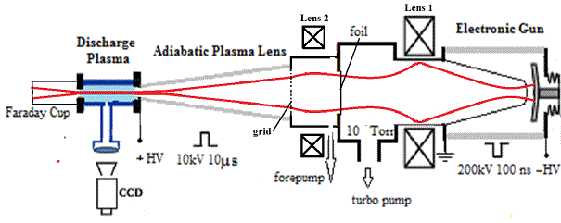

Fig. 1. The experimental installation scheme.
At present main adjustment and alignment works of the electron beam focusing system were performed. As a result of numerical and experimental researches the following electron beam exit parameters were obtained: beam diameter is less than 10 mm and beam current - 50 A. This enables us to start injection of the beam in the discharge tube and to begin studying of a Z-pinch formation with initiation of the discharge by an electron beam. The results of the first carried out investigations are presented in the report.
References
- A.A. Drozdovsky, A.V. Bogdanov, R.O. Gavrilin, A.A. Golubev, S.A. Drozdovsky, I.V. Roudskoy, S.M. Savin, V.V. Yanenko "An Electronic Gun with the Adiabatic Plasma Lens", RUPAC'14, Obninsk, 2014., www.jacow.org.

