NUCLEAR FUSION in the potential well of a virtual cathode of a nanosecond vacuum discharge
A.V. Agafonov², V.A. Bogachenkov², V.T. Karpukhin¹, Yu.K. Kurilenkov¹, A.V. Oginov², I.S. Samoylov¹, and K.V. Shpakov²
¹Joint Institute for High Temperatures, Russian Academy of Sciences, Moscow, Russia,
kurilenkovyuri@gmail.com
²Lebedev Physical Institute, Russian Academy of Sciences, Moscow, Russia
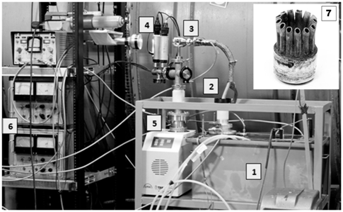Processes of nuclear burning of various elements in the scheme of a compact inertial electrostatic confinement (IED), implemented on the basis of a nanosecond vacuum discharge (NVD) with low-energy hollow cathode are investigated experimentally. Previous experiments [1] and test simulation by particle-in-cell (PIC) method in the framework of electrodynamic code KARAT revealed the fundamental role of the formation of a virtual cathode (VC) and the corresponding potential well (PW) in the interelectrode space of NVD [2]. Deep quasi-stationary potential well (~80% of the voltage applied to the electrodes in the 70–100 kV range) confines and accelerates ions. In particular, the deuterons accelerate up to energies of tens keV. Head-on collisions of fast deuterons in the axial region of the discharge lead to single or multiple (pulsating) outputs of DD neutrons. Formation of controlled PW discharge in the interelectrode space turns it into a kind of nuclear microreactor [3]. Based on this scheme, in NVD with deuterated palladium anode collisional DD fusion was demonstrated earlier [1, 2]. This paper presents the results of a recent series of DD fusion experiments on the anew created experimental stand NVD-2 combined with X-ray and neutron yield diagnostics. The current-voltage characteristics of the discharge, the implemented experimentally regimes of generation of X-ray and DD neutrons are presented and discussed. The experimental results are compared with the results of PIC simulation of the nuclear DD fusion processes in NVD using electrodynamic code KARAT. The possibilities and prospects for increasing the efficiency of nuclear fusion in the IED scheme on the base of NVD with deuterated palladium anode are discussed.
Figure. NVD-2 Stand:
1 oil-filled Marx-type generator, 2 high-voltage output with joint, 3 vacuum chamber with anode assembly, 4 vacuum sensors, 5 pumping system,
6 vacuum gauge, 7 anode assembly (PdD_{x}).

This work was supported by grant No.14-50-00124 of the Russian Science Foundation.
References
- Kurilenkov Yu.K., Skowronek M., and Dufty J. J. Phys. A: Math & Gen, 2006, 39, 4375.
- Kurilenkov Yu.K., Tarakahov V.P., Gus’kov S.Yu., et al. J. Phys. A: Math & Theor, 2009, 42, 214041; Kurilenkov Yu.K., Tarakanov V.P., Guskov S.Yu., et al. Contrib. Plasma Phys. 2011, 51, 427.
- Robert L. Hirsch. Where to Look for Practical Fusion Power. 14th U.S.-Japan IECF Work-shop, October 2012, University of Maryland, USA.

