Conductivity and electrogeneration of solid body dielectrics under high power sxr radiation
V.I. Zaitsev, I.A. Barykov, A.V. Kartashov, O.V. Terentev, and N.B. Rodionov
Troitsk Institute Innovation & Fusion Research, Troitsk, Moscow oblast, Russia vzaitsev@triniti.ru
Results of researches of the effects сurrent arising in such typical dielectrics as sapphire (Al₂O₃) and optical glass (SiO₂) under the influence of soft x-ray radiation are given (energy of quanta 20÷5000 эВ). Measurements were taken on the thermonuclear Angara-5-1 installation (current 3÷4 MA, impulse duration 10 ns). Z-pinch plasma, arising in loading under the influence of the megaampere currents was a source of radiation. Maximum power of a pinch radiation is ~ 5 TWt. Measurements were taken at distance 3 meters from a source, where intensity of the radiation flow was (1÷5)•10⁶ of Wt/cm².
Examinees samples of dielectrics had a form of disks (diameter ~ 1 cm, thickness 0,05 cm). Dielectrics face parts was covered by a contact layer of metal (Al, Au, thick 300 Ẳ) and was the part of the electric source load. The x-ray impulse getting caused the current impulse in as electric circuit which was measured by an oscilloscope,. It is shown that the form of the arising impulse with a sufficient accuracy repeats the impulse of x-ray radiation registered by regular sensors of installation. The main part of measurements was made for optical glass dielectric.
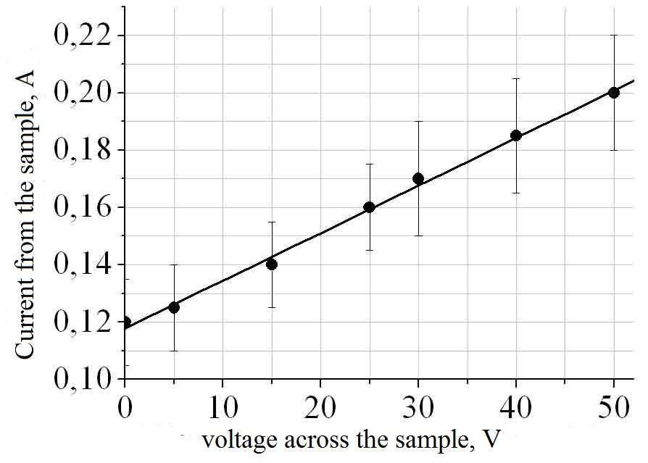The analysis of the current responses corresponding for various radiation levels and various electric field into samples allows to draw the following conclusions for optical glass:
Fig. 1. The dependence of the current in the sample of the applied voltage at a power of radiation of ~ 2 • 10⁶ W/cm²
- the current arising in dielectric (fig. 1.) (power of x-ray radiation ~ 2•10⁶ W/cm², electric field in dielectric E ≈ 1,7•10³ V/cm) increases linearly with inclination dI/ dV ≈ 1,6•10⁻³ А/В;
- dependence of the arising current on of power of the falling radiation within measurement errors also makes ~ 6•10⁻² A/MW;
- current response by zero electric field in dielectric demonstrate that X-ray stimulated EMF on border of contact of dielectric with covering metal.
Authors consider that the cause of the current without applied voltage is generаtion of the "hot" electrons into dielectric by x-ray merger.
Estimates on the base the zonal theory are given for an explanation of the received results.

