STIMULATED BRILLUINE BACKWARD SCATTERING FOR 2D localized PUMP wave
D.K. Solikhov and *S.A. Dvinin
Tajik National University, Faculty of Physics, Tajikistan, Dushanbe, davlat56@mail.ru
*Lomonosov Moscow State University, Faculty of Physics, Russia, Moscow,
dvinin@phys.msu.ru
The interest to stimulated Raman scattering is maintained for a long time due to problems of electron acceleration by a laser beam [1], laser fusion [2], compression and amplification of laser pulses [3], plasma diagnostics [4] and others. In this paper we consider the problem of calculating of wave amplitudes and the intensity of the scattered radiation. The pump wave is supposed to be localized in 2D space domain with size L₁ along pump wave propagation direction and L₂ in the transverse one. The probe wave falls on the region of pump wave localization. Sound wave is generated due to the nonlinear interaction in the plasma. Synchronism conditions ,
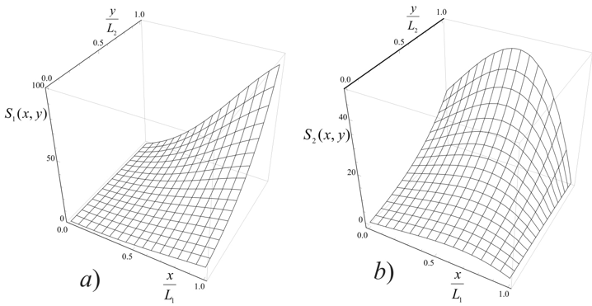  Fig. 1. The spatial dependence of the amplitude of the sound (a) and scattered (b) waves with a small excess of the threshold [7, 8], the scattering angle θ = 3π / 4 and α = 1. | for waves are satisfied. In contrast to previous work [5, 6] backward scattering is investigated. It means that the size of the scattering region is sufficiently small and the absolute instability [7, 8] is absent. In this work amplitude of the scattered and sound waves are calculated as a function of the size of the interaction region of L₁ and L₂ and the incident angle the probe wave. The
example of spatial field distribution is shown on fig. 1.
The case of subthreshold pump wave field (probe wave is scattering on a bounded plasma), weak above-threshold (low gain mode) case and strong superthreshold instability case is investigated. The threshold of convective instability is determined by concurrence of collisional absorption, wave’s energy transfer in the transverse direction and the transformation of energy of the pump wave to the probe wave and sound wave. Knowing the amplitude of the scattered wave gives the possibility to calculate the integral scattering intensity, which usually is measured in the experiment.
References
- Esarey E., Schroeder C.B., Leemans W.P. Rev. Modern Phys. 2009, 81, 1229.
- Tabak M., Hammer J., Glinsky M.E. et al. Physics of Plasmas, 1994, 1, 1626.
- Strickland D., Mourou G. Opt. Commun. 1985, 55, 447.
- Cornella B.M., Gimelstein S.F., Shneider M.N. et al. Optics express, 2012, 20, 12976.
- Solikhov D.K., Ovchinnikov K.N., Dvinin S.A. Moscow University Physics Bulletin, 2012, 39.
- Солихов Д.К., Двинин С.А. XLII Международная (Звенигородская) конференция по физике плазмы и УТС. Звенигород, 2014, с. 322.
- Kroll N.M J. Apple. Phys., 1965, v.36, p. 34 – 43
- Bobroff D.L., Haus H.A. // Apple. phys., 1967, 38, №1, р.390.

