modified drift-diffusion model of the penning discharge at pressure OF 1.0 mtorr
Surzhikov S.T. and *Kuratov S.E.
Institute for problems in mechanics Russian academy of sciences, Moscow, Russia
*All-Russian Research Institute of Automatics, Moscow, Russia
With the use of numerical simulation, we study the spatial structure of the Penning discharge, used as a source of ions in the gas-filled neutron tube [1]. The steady-state discharge in molecular hydrogen is analyzed. Schematic of the discharge is shown in Figure 1,a. The following initial conditions are considered: electromotive force of the current E = 2500 V, the ohmic resistance of the external circuit of 3 kOhm, pressure 1.0 mTorr, magnetic field induction of B_{x} = 0.1 T.
The two-fluid and two-temperature drift-diffusion model (DDM) is used. This model was described in detail in [2]. However, given the specificity of this discharge (low pressure, large path length, the presence of a magnetic field), modification of the classical DDM has been performed. In the modified DDM, the mobility of ions and electrons depends nonlinearly on the electric field. This modification allows get a reasonable agreement with the current-voltage characteristic, observed in the experiment and, thus, gain an understanding of the spatial structure of the discharge.
Figure 1,b,c shows the distribution of ions and electrons in the discharge gap (in 10¹⁰ cm⁻³).
A feature of the obtained numerical solution is the cumulation of the discharge in the central near axis region and, consequently, the formation of the ion beam emerging from the holes in anti-cathode. Also of note is great thicknesses of the cathode's layers above the cathode and anti-cathode (are not shown in the figures).
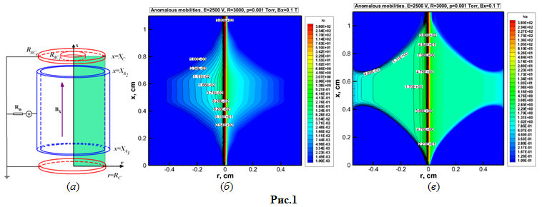
References
- Markov V.G., Prpkhorovich D.E., Sadilkin A.G., Shchitov N.N. Determination of the corpuscular emission energy characteristics for the ion sources of gas-filled neutron tubes. Advances of the Applied Physics. 2013. Vol.1. No.1. pp.23-29.
- Surzhikov S.T. Computational Physics of Electric Discharges in Gas Flows. 2013, Walter de Gruyter GmbH, Berlin/Boston. 428 p.

