Study of GAMs radial structure with multislit analyzer of heavy ions
S.E. Lysenko, A.V. Melnikov, L.G. Eliseev, S.V. Perfilov and V.N. Zenin
NRC "Kurchatov Institute", 123182 Moscow, Russia, Lysenko_SE@nrcki.ru
The five-slits energy analyzer of heavy probing ions was installed on the T-10 tokamak. It allows us directly measure the plasma potential, electric field and their fluctuations. At lowered magnetic field of tokamak, B=1.5 T, the region of measurement by heavy ion beam probing (detector grid) covers the most part of plasma cross section. The part of detector grid formed with various energies of probing beam and injection angles is shown in the left part of Fig. 1. Short fat dashes designate the simultaneous sample volumes for all five slits of analyzer. During the discharge the injection angle was varied each 70 msec to receive the signal from sample volumes placed at different radii. The right part of figure presents delays of potential oscillations in the frequency range of geodesic acoustic mode (GAM) [1] (thin black curve) and its satellite (fat red curve) detected by edge slits for two sample volumes. Figure shows that at the radius r=26 cm the delays for GAM and satellite has different signs, that is they move in opposite directions, but at r=27 cm both GAM and satellite move outward. At radii r < 26 cm both GAM and satellite propagate inward, and at r > 27 cm they propagate inward. We suppose that GAM is originates at 26-27 cm and then propagates over the whole cross section. The velocity of GAM propagation is about 3 km/s. Previously we used this analyzer to study the poloidal structure of potential perturbation at GAM frequencies. It was shown that the poloidal mode number is m=0, therefore we suppose that GAM propagates in the radial direction. This estimation of GAM origin localization corresponds to the temperature estimation of GAM localization [2].
The work was funded by Russian Scientific Foundation project No 14-22-00193.

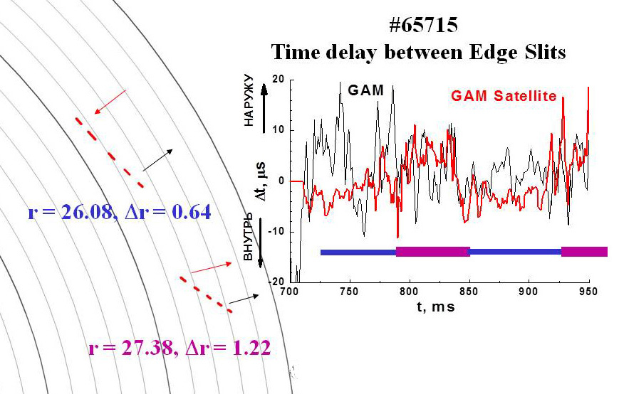

Fig. 1. Part of detector grid and traces of time delays of potential oscillations in the frequency ranges of GAM and satellite. Narrow and wide parts of horizontal line mark times of detecting upper and lower sample volumes.
References
- Melinkov A.V. et al., Plasma Phys. Control. Fusion, 2006, v. 48, p. S87.
- Zenin V.N. et al., This conference.

