study of frequency structure Geodesic acoustic mode in the t-10 tokamak
V.N. Zenin, A.V. Melnikov, S.A. Grashin, L.G. Eliseev, S.E. Lysenko, R.Yu. Solomatin and S.V. Perfilov
NRC "Kurchatov Institute", 123182 Moscow, Russia, e-mail: vitalyzenin@mail.ru
Geodesic acoustic modes (GAMs) are high-frequency branch of zonal flows. Now they are considered as a possible mechanism of the plasma turbulence self-regulation [1]. In the circular tokamak T-10 (B = 1.5—2.5 T, R = 1.5 m, a = 0.3 m) GAMs were studied by heavy ion beam probing (HIBP) [2]. A theory predicts that in the one-fluid approximation the GAM frequency is proportional to the ion sound velocity, i.e. to the square root of the electron temperature, f ~ √(T_{е}). However, experiments on T-10 and other devices have shown that the frequency of electric potential and density oscillations in the GAM range is not followed by the radial variation of local temperature. In contrast, the GAM frequency of potential oscillations is almost constant along the minor radius [3]. So, GAM on the potential develops feature of the global Eigen mode of plasma oscillations. In the presented report, the GAM frequency f_{exp} was measured in the wide range of density variation n_{e} = (1.5—6.0)×10¹⁹ m⁻³ and plasma current I_{pl} = (140—300) kA. We show that the measured GAM frequency rises with averaged electron temperature. Moreover, f_{exp} is proportional to theoretically predicted f_{th} with coefficient k(ρ): f_{exp} (ρ) = k(ρ) f_{th}(T_{e}(ρ)), where k(ρ) decreases with ρ. We suppose that GAM is excited in the region, where f_{exp}(ρ) = f_{th}(ρ), or k(ρ) = 1. If we take into account only T_{e}, then GAM is excited at ρ = 0.75. If we additionally take into account the ion temperature, then this radius is estimated as ρ = 0.9.
We have found that GAM is accompanied by a satellite mode. The frequency of satellite is higher than the GAM frequency, and it also corresponds to the square root dependency: f_{satellite} = f_{GAM} + const. Data of Langmuir probes and HIBP evidence that the outer boundary of satellite existence is some narrower than for the main mode.
The work was funded by Russian Scientific Foundation project 14-02-00193.

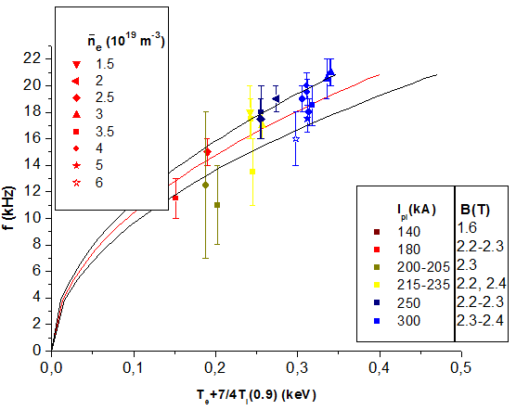

Fig. 1. Experimental GAM frequency agrees with theoretical expectations for the temperatures at the radius ρ = 0.9.

References
- Fujisawa A. et al., Nucl. Fusion, 2007, v. 47, p. S718.
- Melnikov A.V. et al., Problems of Atomic Science and Technology, series ”Plasma Physics”, 2013, No 1(83), p. 30-32.
- Melnikov A.V. et al., JETPh Letters, 2014, v. 100, p. 633-638.

