plasma accelaration in plane chanNel in two-fluid MHD approximation

Gavrikov M.B. and Savelyev V.V.

Keldysh Institute of Applied Mathematics RAS, Moscow, RF, [nadya_p@cognitive.ru](mailto:nadya_p@cognitive.ru), [ssvvvv@rambler.ru](mailto:ssvvvv@rambler.ru)

For plane channel in the two-fluid approximation of the cold plasma stationary distribution (in dimensionless units) of the longitudinal velocity of the plasma flow *U* and of the transverse magnetic field *H* can be found from the equations [1,2]



where , *ρ0, U0, H0* - plasma parameters at the entrance of channel, σ - conductivity.

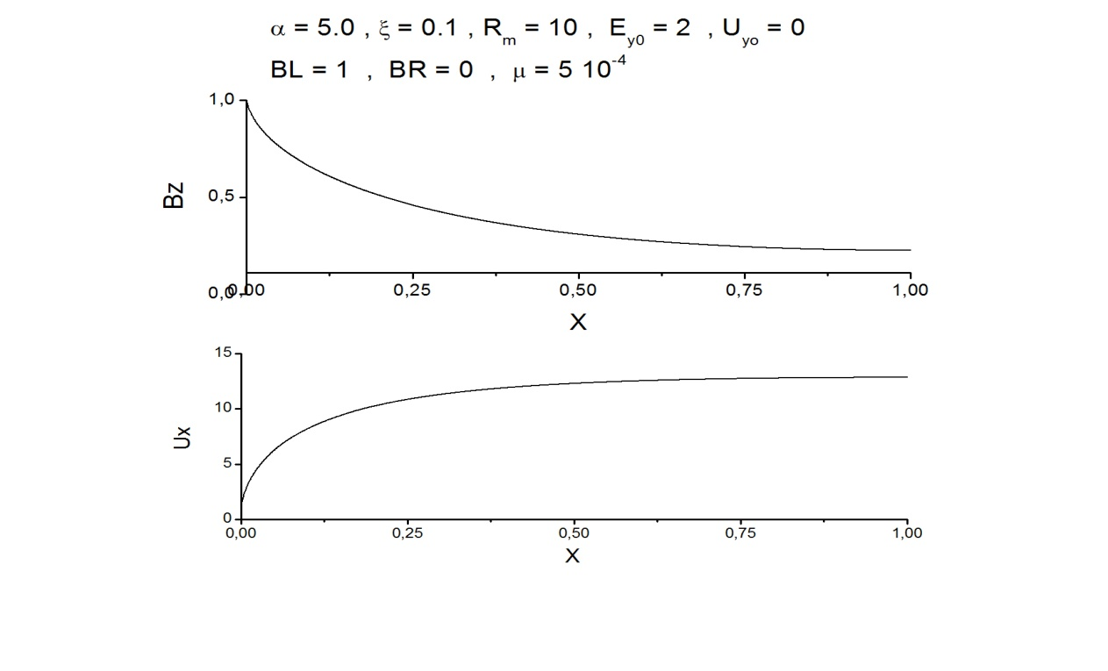The paper shows that for plasma with there are regimes of flows with great acceleration. The length of the acceleration zone of the order  (*cm*) and it is located at the entrance of the channel. In the single-fluid MHD such acceleration does not exist. The dependence of these flows on the parameters of the problem (...) is investigated. As an example, the figure shows the distribution of the transverse magnetic field and the longitudinal velocity

References

1. Gavrikov M.B., Savelyev V.V., Journal of Mathematical Sciences, V.163, N.1, 2009, pp 1-40.
2. Гавриков М.Б., Савельев В.В., Шмаровоз Г.В., Препринт ИПМ им. М.В.Келдыша, N 52, 2009, c. 3-26 (in Russian).