The Role of Current Filaments in a Long Spark in Air
A.V. Oginov, A.A. Rodionov, K.V. Shpakov
Lebedev Physical Institute of RAS, Moscow, RF, oginov@lebedev.ru
Recent studies of natural lightnings show that the high-energy radiations are generated during thunderstorms. Besides hard x-ray and gamma radiation [1], a neutron generation is also observed [2]. In a laboratory long spark discharge with the parameters similar to lightning the neutron generation is observed also [3]. The model and mechanism possible to explain the generation of hard x-rays and neutron bursts during atmospheric discharge in air is under discussion.
The formation of 500–700 mm long sparks in air on ERG installation at LPI (1 MV, 60 kJ, 150 ns risetime) at different initial electric field distributions was investigated. A volumetric streamer corona of 0.2–1.0 kA on both of electrodes at atmospheric pressure was followed by a formation of bright channel of 12 kA leader. A fine microstructure of a leader stage of a 200-1200 ns discharge was observed.
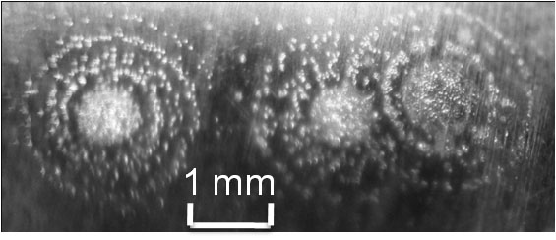
Fig. 1. Autographs of discharges on the electrodes surface.
The distribution of µm-scale microchannels over the mm-size leader cross section near the electrodes and in the gap was investigated. Optical and autograph diagnostics were used to estimate a current density in a single microchannel. It was shown earlier [4] that the formation of leader current structure can be attributed to the instability of initial ionization wave front producing streamers. Another possibility is to consider current filaments as the quasi-equilibrium structures with strong radial electric field due to Hall effect [5]. The possibility of current carrying by the relativistic electrons drifting in the crossed electric and magnetic fields and the acceleration of ions to keV energy range in a strong radial electric field at experimental conditions was examined. The observed experimental results are compared with the filament model estimations of x-ray emission intensity and neutron flux.
The role of vortex field structures as a possible mechanism for generation of high energy radiations in atmospheric discharge was considered.
This work was supported by the RFBR grants 13-08-01379, 14-08-31397.
References
- H. Tsuchiya, T. Enoto, T. Torii et al. Observation of an Energetic Radiation Burst from Mountain-Top Thunderclouds, Phys. Rev. Lett. 102, 255003 (2009).
- A.V. Gurevich, V. P. Antonova, A. P. Chubenko et al. Strong Flux of Low-Energy Neutrons Produced by Thunderstorms, Phys. Rev. Lett. 108, 125001 (2012).
- A. V. Agafonov, A. V. Bagulya, O. D. Dalkarov et al. Observation of Neutron Bursts Produced by Laboratory High-Voltage Atmospheric Discharge, Phys. Rev. Lett., 111, 115003 (2013).
- A.V. Oginov, K.V. Shpakov, E.V. Akkuratova, Structure of current channels in a long spark in air, Book of abstracts of 24th Symposium on Plasma Physics and Technology, 14–17 June 2010, Prague, p. 51.
- A.V. Gordeev, T.V. Losseva, Book of Abstracts of XXXIII International Conference on Plasma Physics and CF, February 13 – 17, 2006, Zvenigorod, p. 246.

