FORMATION OF A STRONG ELECTRIC FIELD AND EXCITATION OF MICROPLASMA DISCHARGES AT THE EDGE OF A DIELECTRIC FILM ON A METAL SURFACE IN A PLASMA FLOW
A.S. Sakharov, V.A. Ivanov, M.E. Konyzhev
GPI RAS, Moscow, Russia, sakh@fpl.gpi.ru
Results are presented from experimental and analytical studies of the processes resulting in the excitation of microplasma discharges on a metal surface partially covered with a thin dielectric film in an external plasma flow [1]. It is shown experimentally that microplasma discharges are excited at the interface between the open area of the metal surface and the region covered by the dielectric film. The process of microplasma discharge excitation is investigated depending on the thickness of the dielectric film deposited on the metal. It is found that, for a film thickness of 1 μm, the probability of microplasma discharge excitation is close to unity. As the film thickness decreases below ~10 nm or increases above ~10 μm, the probability of microplasma discharge excitation is reduced by more than two orders of magnitude. A two-dimensional kinetic numerical code is developed that allows one to model the processes of the Debye sheath formation and generation of a strong electric field near the edge of a finite-thickness dielectric film on a metal surface in a plasma flow for different configurations of the film edge (Fig, 1). It is shown that the maximum value of the electric field is reached at the film edge and amounts to E_{max} ≈ |φ₀|/2d (where φ₀ < 0 is the electric potential applied to the metal and d is the film thickness), which for typical conditions of experiments on the excitation of microplasma discharges on metal surfaces (φ₀ ≈ −400 V, d ≈ 1 μm) yields E_{max} ≈ 2 MV/cm. The experiments and kinetic simulations confirm the qualitative idea about the mechanism for excitation of microplasma discharges on a metal surface covered with a dielectric film as a result of the formation of a strong electric field at the film edge due to the charging of the film surface in the plasma flow.
This work was supported by the RFBR, project no. 13-08-01174-a.
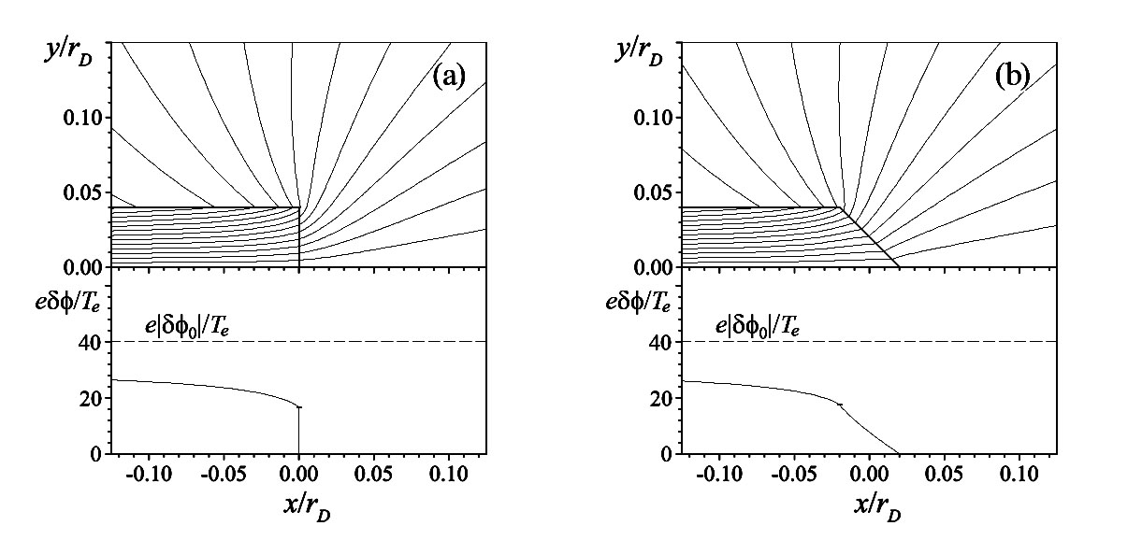
Fig. 1. Distribution of the electric potential near the film edge and profile of the potential of the film surface relative to the cathode δφ in a steady state at φ₀ = −40T_{e}/e, d = r_{D}/25, and ε = 2 for the inclination angles of the film edge (a) 90° and (b) 45°. The potential difference between neighboring equipotential lines is Δφ = 2T_{e}/e.
References
- Ivanov V.A., Sakharov A.S., Konyzhev M.E., Usp. Prikl. Fiz., 2013, No. 6.

