Pulsed DISCHARGE IN HUMID AIR FOR MEDICAL APPLICATIONS
N.V. Ardelyan*, V.L. Bychkov, I.V. Kochetov, K.V. Kosmachevskii*
Moscow Radiotechnical Institute of Russian Academy of Sciences, 132, Varshavskoe shosse,
Moscow, Russia, 117519
*M.V. Lomonosov Moscow State University, Leninskie Gory, Moscow, Russia, 119991
We have considered plasmas in humid air when water molecules content (volumetric) in air lies in the range 0.5-4% of H₂O corresponding to a discharge impact at distances of 0- 0.85 mm from the surface of a human skin during time when the gaseous temperature rise from 300 to 385 K possible at medical applications.
Calculation results obtained for a discharge heating of air-water mixture in time with 0.5 and 3.9 % of H₂O at external breakdown field 30 kV/cm. The discharge temperature rises with rise of water concentrations due to fast relaxation of vibrationally excited water molecules.
Calculations show that during a pulse of the discharge larger than ~5 μs takes place heating of air for ~55 K, by this time O₃, O and NO become main small active components. At that an amount of O₃ rises with time.
All these components are active components leading to decontamination of cells. At finishing of the discharge action O and NO components participate in the following reactions
,
,
at that the first one is most probable since it is a three-body reaction, so even the decaying plasma can realize the sterilization effect.
Presence of these components convenient for sterilization applications and in agreement with results of the experiments where application of a barrier discharge lead to biological decontamination of Escherichia coli cells.
For practice the calculation results for a discharge heating of air-water mixture in time with 0.5 and 1.7 % H₂O correspond to the height of about 0.85 mm and 0.1 mm over the water surface at evaporation rate of 2⋅10⁻⁵ kg/ (m⋅s).
Necessary for such an impact devices at indicated distances from the skin surface can be non-equilibrium and pulsed discharges.
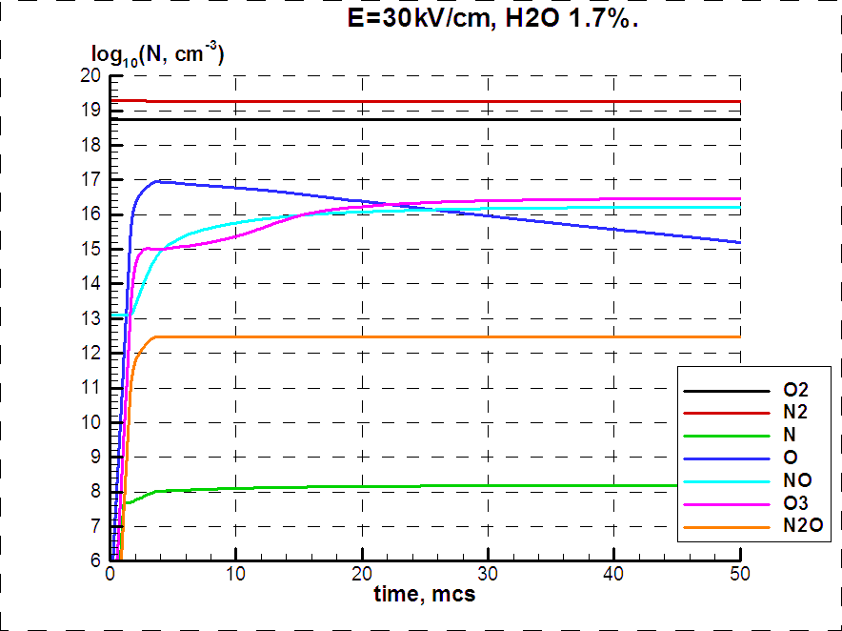
Fig.1 Evolution of neutral molecules concentrations in time molecules in the mixture of air and water E/N= 110 Td.

