investigation of stationary tokamak plasma flows in two-fluid MHD APPROXIMATION

Gavrikov M.B., Savelyev V.V.

Keldysh Institute of Applied Mathematics RAS, Moscow, RF, [nadya_p@cognitive.ru](mailto:nadya_p@cognitive.ru), [ssvvvv@rambler.ru](mailto:ssvvvv@rambler.ru)

The report presents the results of a numerical study of steady flows of plasma in the tokamak. The ions are at rest () and are confined by the electric field. The electrons carry electric current. This is done with a full account of their inertia, the influence of which leads to an additional equation for the function of the total current  which is absent in MHD plasmastatic. As a result, instead of the single Grad-Shafranov equation for the function of the magnetic flux we have [1], the system of two equations for the function and the total current 

 (1)

System (1) is closed by the integrals of Bernoulli (energy) and the angular momentum from which we can find values of azimuthal current  and particle density 

 (2)

Here and are arbitrary given functions. Function determines the entropy of the electrons,  is their enthalpy. The figure gives an example of the level lines  (lines of the poloidal magnetic field) for various choices of parameters of the problem.

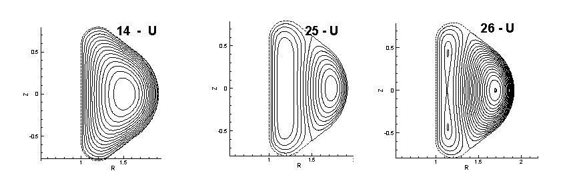

References

1. Gavrikov M.B., Savelyev V.V., Journal of Mathematical Sciences, V.163, N.1, 2009, pp 1-40.