STUDY OF GEODESIC ACOUSTIC MODES PRoRERTIES ON THE T-10 TOKAMAK
A.V. Melnikov, L.G. Eliseev, V.N. Zenin, S.A. Grashin, *L.I. Krupnik, S.E. Lysenko, S.V. Perfilov, E.A. Sorokina, Solomatin R.Yu.
NRC "Kurchatov Institute", 123182 Moscow, Russia, lysenko@nfi.kiae.ru
*Institute of Plasma Physics, NSC KIPT, 310108 Kharkov, Ukraine
Geodesic acoustic modes (GAMs) are high-frequency branch of zonal flows. They are actively studied as one of possible mechanisms of the plasma turbulence self-regulation [1]. Modes within GAM frequency range are systematically investigated on the T-10 circular tokamak (B=1.5—2.5 T, R=1.5 m, a=0.3 m), using the heavy ion beam plasma probing, correlational reflectometry, Langmuir probes and other diagnostics [2]. Here we present results of recent experiments for investigation of GAMs on the plasma potential and density in discharges with Ohmic and ECR heating. The dynamic of GAMs in discharges with various I and B, and in a wide range of plasma densities: n_{e}=(0.6—4.7)×10¹⁹ m⁻³with temperature T_{e}(0)<1.3 keV was studied. It was shown that: (i) the GAM frequency has the square root scaling with the temperature, f ~ √(T_{e}); (ii) when the density n_{e} increases, the GAM amplitude decreases that may be explained by collisional damping of GAM. The phase shift between the GAM oscillations of potential and density approximately equal to π/2; (iii) it was at first time measured that GAMs on the potential have the poloidal mode number m=0. All before mentioned experimental findings correspond to theoretical predictions [3].
Also it was shown that the GAM amplitude and frequency is constant along the radius in the zone of observations, 0.3<ρ <1, in a wide range of studied regimes (Fig. 1.) This fact has not theoretical explanation. However, it was calculated in a specific case, which was not realized in presented experiment [4].
The work is supported by Rosatom, Contract H.4x.44.90.13.1101, and by Rosnauka, Grant NSh 5044.2012.2.
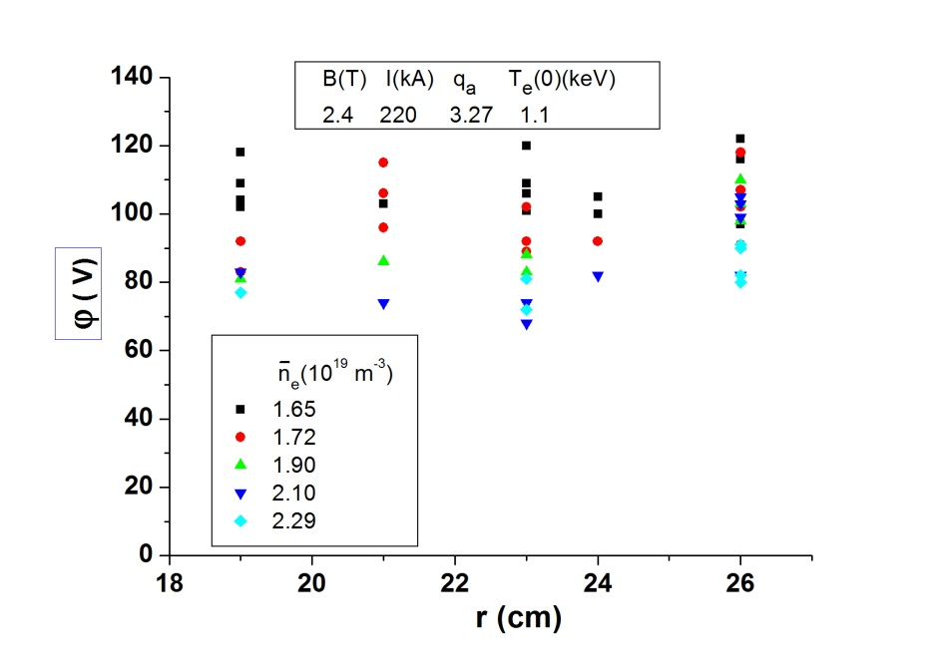

Fig. 1. Amplitude of GAM on the potential is independent on the radius in a wide range of densities.

References
- Fujisawa A. et al. Nucl. Fusion, 2007, v. 47, p. S718.
- Melnikov A.V. et al. Plasma Phys. Control. Fusion, 2006, v. 48, p. S87.
- Diamond P.H. et al, Plasma Phys. Control. Fusion, 2005, v. 47, p. R35.
- Ilgisonis V.I., Lakhin V.P. and Sorokina E.A., 40th EPS Conference, 2013, Rep. P2.188.

