determination of maximum amount of confined particles in linear Paul trap at atmospheric pressure in air
Deputatova L.V., Filinov V.S., Lapitsky D.S., Pecherkin V.Ya., Syrovatka R.A., Vasilyak L.M., Vladimirov V.I.
Joint Institute for High Temperatures of the Russian Academy of Sciences,Moscow, dmitrucho@yandex.ru
In this work the behavior of the charged dust particles in the linear Paul trap is studied. The behavior of dust particles is simulated by Brownian dynamics. Regions of dust particle confinement were found in wide range of parameters: size of dust particles, its density and charge; dimensions of linear Paul trap, frequency and voltage at electrodes of the trap. Results of simulation agree with experimental results.
In this work regions of dust particle confinement were found in wide range of parameters. The dynamics of a cloud of dust particles at different ratio Q_{p}/m_{p} in linear Paul trap at high gas pressure was studied where Q_{p} and m_{p} are dust particle charge and mass respectively.
Maximum amount of confined particles in linear Paul trap [1] as function of ratio Q_{p}/m_{p} and frequency f of electrodynamics field was found. Maximum amount of confined particles at experiment was 50-100 pfrticles and at simulation – 156 particles.
Comparison of simulation and experimental result of dynamics of dust particle assembly was performed. At similar conditions: type of dust particles, size and its charge, dimensions of linear Paul trap and applied voltages results of simulation agree with experimental results. Comparison of simulation results of dust particle catching (ρ_{p} = 0.38*10⁴ kg/m³, r_{p} = 10 μm, Q_{p} = 4,5*10⁵ e) and experimental results (ρ_{p} = 0.38*10⁴ kg/m³, r_{p} = 10 μm, Q_{p} = 4,5*10⁵ e) is shown at pic. 1.
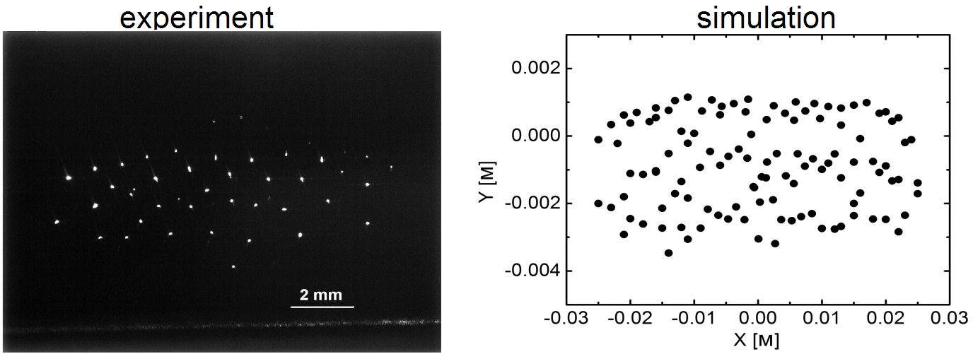
Pic. 1. Slice of confined cloud of dust particles 2 mm width (side view).
Trap dementions: L_{m} = 15 cm, L_{b} = 1,3 cm, L_{h} = 6 cm, end electrodes 5 length – 4,5 cm, diameter of each electrode d = 3 mm. Applied voltage at electrodes 1 and 2 is U_{ω*}sin(ωt), at 3,4 – -U_{ω*}sin(ωt). At end electrodes repulsive voltage U_{end} is applied. Parameters of experiment: f = 50 Hz, U_{ω} = 4.4 kV, U_{end} = 900 V, Q_{p} (experiment) = 5-5*10⁵ e, Q_{p} (simulation) = 4.5*10⁵ e, ρ_{p} = 0,38*10⁴ kg/m³, r_{p} = 10 μm, Т = 300 K, η = 17,2 μPa*s.
References
- Vasilyak L.M., Vladimirov V.I., Deputatova L.V., Lapitsky D.S., Molotkov V.I., Pecherkin V.Ya., Filinov V.S., Fortov V.E. Coulomb stable structures of charged dust particles in a dynamical trap at atmospheric pressure in air // New Journal Physics. 2013. 15. 043047.

