Investigation of weibel instability role in laser interaction with overdense plasma by numerical simulation
A.Yu. Perepelkina, V.D. Levchenko, I.A. Goryachev
Keldysh Institute of Applied Mathematics RAS
The possibility of magnetic field appearance in plasma due to Weibel filamentation instability in known for a long time. Since the process began to be considered the probable reason of large scale stable magnetic fields in intergalatic plasma, as well as in fast ignition experiments, it was given even more attention in plasma physics research.
The applicability of analytical estimations, achieved through linear theory, has its limits. Due to the speed of instability process and small scale of its initial stages the experimental equipment does not give credible information. So, while describing the mechanisms of instability process in various systems, researchers base their theories on the results of numerical simulations.
Since the theory of kinetic simulation of plasma appeared such experiments were carried out many times for the study of instability mechnisms in simple statements to verify analytical estimates, as well as for the research in relevant problems, such as the accelearion of particles by laser pulse. In such simulation various calibrations and approximations are used to enable the result aquisition in reasonable time period on available computers. Among the commonly used approximations which may alter the process of nonlinear phenomena in plasma, one can note the use of 2D3V geometry, and mesh steps of the size of the studied oscillation scale.
With the development of computational equipment and algorithms the number of necessary approximations is decreasing, and with the advance of simulation codes with the use of locally recursive non-locally asynchronous algorithms the main limations on the numerical parameters of the problem had lost their relevance.
In this work the efficient kinetic plasma simulation code CFHall, based on particle-in-cell method, is used.
Accounting for previous research results the numerical parameters sufficient for adequate description of studied process were chosen. The chosen parameters were verified for the investiogation of Weibel instability in a problem statement with simple initial conditions (a system with two relativistic electron beams) [1].
The series of simuations were carried out for the problem of particle acceleration in the laser pulse interaction with overdense plasma layer. The dependency of the ratio of energy transferred to magnetic field formation on laser amplitude was found to be nonmonotonic with the maximum value over 4%.

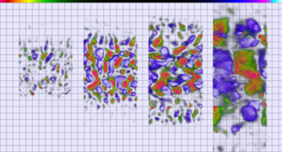
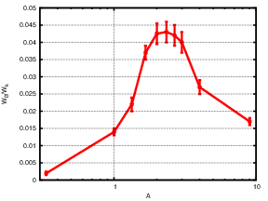
Рис.1. Filamentation in magnetic field in laser interaction with overdense plasma. The dependency of the ratio of energy transferred to magnetic field formation on laser amplitude
References
- CFHall Code Validation with 3D3V Weibel Instability Simulation, A Yu Perepelkina et al 2013 J. Phys.: Conf. Ser. 441 012014

