PORT PLUG TEST FACILLITY FOR ITER – THE STAGE OF DESIGN AND MANAFACTURING OF THE GASKET TEST STAND

\*Allin M., \*Mitrofanova E., \*Minakov V., \*Rumyantsev Yu., \*Pravdina I., Krasilnikov A., Romannikov A., \*\*Levesy B., \*\*Cerisier T.

Project Center ITER, pl. Kurchatova I., Moscow 123182, Russia  
\*JSC “Cryogenmash”, 143907 Moscow reg., Balashikha, Russia, [allin@cryogenmash.ru](mailto:allin@cryogenmash.ru)  
\*\*ITER Organization, Route de Vinon sur Verdon, 13115 Saint Paul Lez Durance, France

Specialized testing facilities are designed and manufactured for executing heating, vacuum and functional tests of ITER thermo-nuclear reactor port-plugs.

In order to guarantee the tightness of the sealing between testing vacuum chamber and port-plug the specialized testing mock-up should be developed for testing possible types of sealing.

Actual status of development of the specialized mock-up for testing of vacuum sealings is: design is finished, manufacturing to be finished in 2013, tests to be done by May, 2014.

The report describes the design of the specialized mock-up for testing of vacuum sealings, peculiar properties of sealing between port-plugs and testing vacuum chamber, characteristics of tested types of sealings, testing program, and criteria of selecting the sealing.

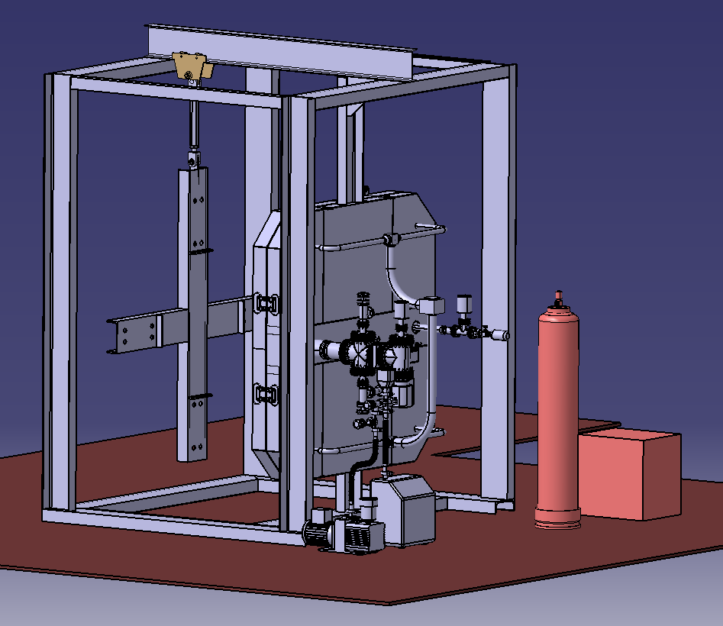

General view of Mock-up for testing of vacuum sealing.