THECNICAL ASPECTS OF FINAL DESIGN OF PORT PLUG TEST FACILLITY FOR ITER
Romannikov A., *Allin M., *Mitrofanova E., *Minakov V., *Rumyantsev Yu., *Pravdina I., Krasilnikov A., **Levesy B., **Cerisier T.
Project Center ITER, pl. Kurchatova I., Moscow 123182, Russia
*JSC “Cryogenmash”, 143907 Moscow reg., Balashikha, Russia, allin@cryogenmash.ru
**ITER Organization, Route de Vinon sur Verdon, 13115 Saint Paul Lez Durance, France
Tests on the port plugs at operating temperature before installation on the machine and after refurbishment are mandatory to prepare the ITER machine to effective work. The ITER port plug test facility (PPTF) provides the possibility to test upper and equatorial port plugs before installation on the machine.
“Cryogenmash” and “Project Center ITER” have carried out construction and calculations of all the subsystems of the test stand at the current Final Design stage. The major subsystems are:
- test tank;
-vacuum system;
-heating system;
- control system;
- PSS system and etc.
The report presents some technical features of subsystems mainly in the frame of integration of subsystems in the "Hot Cell" of ITER.

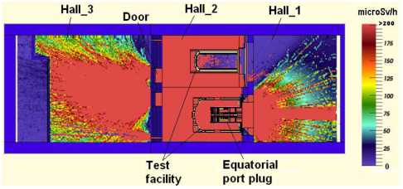

The example of dose rate distribution in the horizontal cross-section (Z =55 cm) of PPTF with EPP in Hot Cell

